|  |  |  |
| --- | --- | --- |
| Etude préliminaire de faisabilité pour le traitement de la noix de cajou en Côte d’Ivoire | February 17  2015 | |
| Demandé par S3C, Abidjan, Cote d'Ivoire Octobre 2014-Février 2015 | | Redigé par William Morgan |

Table of Contents

**A. Executive Summary1**

**B. The Market For Cashew Nut2**

An overview of the cashew market both for raw cashew nuts and kernels. Import, export and growth figures as well as a brief review of the domestic processors.

**C.** **Possible Constraints for Processing**.......................................................................................................**10**

Examining the possible constraints a processor would encounter while processing in Cote d'Ivoire as well as S3C's plans to mitigate the constraints.

**D. Introduction to the Process**...................................................................................................................**14**

An introduction to the process of obtaining kernels from the shells and an in depth examination of each step in the process.

**E.** **Review and Comparison of the Machinery on the Market**...................................................................**29**

Further examination of each step in the process and the machines that are that are used in the different processing centers of the world.

**F. Machinery to be chosen for S3C**............................................................................................................**32**

A review of the machinery to be chosen for the project of S3C and the reasoning behind these machines.

**G. Financial Analysis**.............................................................................................................................**47-72**

Analysis and projections for the investment, production and profitability of the project. Including the expansion plan, changes in required working capital and a 15 year outlook for the project.

**H. Conclusion**..............................................................................................................................................**73**

Concluding remarks.

**I. Sources**....................................................................................................................................................**75**

A. Résumé

1. Périmètre de l’étude et objectif

~~This is study aims to determine the feasibility of constructing a cashew nut processing plant in the Cote d'Ivoire. Multiple production processes and regions will be discussed. It is the intention of S3C to expand its scope from exporting raw cacao, cafe, and cashew to producing processed cashew kernels. This expansion includes the creation of a new entity to take advantage of investment incentives in the country. This production process represents a lucrative opportunity for international export. This is especially true for Western African nations who harvest raw cashews, as the kernels are usually preferable in quality than that of other areas around the world~~. ~~This opportunity is summarized numerously by exerts from reports like the following~~:

Cette étude a pour but de determiner l’opportunité d’implanter une usine de traitement de noix de cajou en Côte d’Ivoire. Nous allons analyser différents processus de production ainsi que les grandes regions productrices. Aujourd’hui, la S.3C a pour objectif de diversifier ses activités de l’exportation des fèves de cacao, de café etde cajou à la production d’amandes de cajou. Cette expansion se fera au travers de la creation d’une nouvelle société aux fins de bénéficier des mesures d’aide à l’investissement en vigueur dans le pays. Ce processus de production réprésente une opportunité lucrative pour l’export. Cela est particulièrement vérifié pour les nations Ouest africaines qui cultivent le cajou brut, et dont les amandes sont préférables en terme de qualité par rapport aux autres regions productrices du monde. Cette potentialité est souvent reprise dans de nombreux rapports d’experts tel que nous pouvons lire dans l’extrait suivant :

*~~"Due to decreasing production levels in Brazil and Vietnam and stable production levels in India, Africa is in the center of attention on the global cashew market. According to the latest projections, Côte d’Ivoire is becoming the largest producer worldwide until 2018. A high demand on high quality kernels worldwide gives (West) Africa a unique opportunity in producing higher quantities of better quality kernels to meet the rising global demand. If global demand cannot be met, high price volatility and unstable prices will be a negative result." - Global cashew market review and outlook 2013-14 (AfricanCashewAlliance)~~*

*“A cause de la baisse du niveau de production au Brésil et au Vietnam et du niveau de production stable en Inde, l’Afrique est au centre d’une attention particulière sur le marché global du cajou. Selon les dernières projections, la Côte d’Ivoire deviendra en 2018 le plus grand producteur mondial. La forte demade mondiale de la meilleure qualité d’amande donne à l’Afrique (de l’ouest) une opportunité unique en produisant en plus grandes quantités, les meilleurs qualités d’amande pour satisfaire la demande globale croissante. Si la demande globale n’est pass satisfaite, l’explosion et l’instabilité des prix constitueront un mauvais résultat.” – Revue du marché global de cajou 2013-14 (African Cashew Alliance)*

~~As stated above, the need for this type of investment is evident and necessary to maintain a stable supply and price of cashew kernels. This project aims to enhance the lives of farmers across the country and will accommodate the government's goal of participating in global value chains. In 2013, the Cote d'Ivoire produced about 500,000 MT of RCN, but the country only had an installed processing capacity of about 60,000 MT (about 12%). According to the Ministry of Agriculture, only 5% of the total production was processed locally and the rest was exported mainly to India or Viet Nam for processing. Cote D'Ivoire also suffers from smuggling, it is estimated that in 2013 almost 65,000-70,000MT were illegally smuggled to Ghana where RCN exporters benefit from no export tax on RCN and the farm gate price is higher. To combat this smuggling and increase the productivity in the cashew sector, The Ministry of Industry and Mines has announced new objectives: by 2016, 35% (about 230,000MT) of the cashew crop should be processed locally and by 2020, 100% of the expected 1,030,000MT harvest should be processed locally. S3C plans operate in-line with these objectiv~~es~~. The scope of the proposed project is for the production facility to have a minimum capacity of 10,000 MT in year one and maximum capacity of 30,000 MT RCN in year 5 (increasing capacity by 5,000 tons each year). This should result a minimum of 2,200MT to 6,600MT of ready-to-consume cashew kernels.~~

Comme signifié plus haut, la nécessité de ce type d’investissement est évidente pour maintenir une fourniture stable et le prix des amandes de cajou. Ce projet vise à améliorer la vie des planteurs à travers le pays. **Il satisfera également le but du gouvernement de aux chaînes de valeurs mondiales.** En 2013, la Côte d’Ivoire a produit environ 500 000 tonnes de noix brut de cajou, mais le pays dispose d’une capacité de transformation de seulement 60 000 tonnes (environ 12%). Selon le Ministre de l’Agriculture, seulement 5% de la production totale ont été transformés localement et le reste a été exporté principalement en Inde ou au Vietnam pour transformation. La Côte d’Ivoire souffre également de la contrebande. L’on estime qu’en 2013 entre 65 000 et 70 000 tonnesont été illégalement exportées à partir du Ghana où les exportateurs de noix brute de cajou bénéficient d’une exoneration de la taxe sur le cajou et le prix bord champ plus élevé. Pour lutter contre la contrebande et augmenter la productivité dans le secteur du cajou, le Ministre de l’Insustrie et des Mines a annoncé de nouveaux objectifs : en 2016, 35% (environ 230 000 tonnes ) des noix de cajou recoltées seraient transformées sur place et en 2020, 100% des 1 030 000 tonnes attendues seraient transformées ici en Côte d’Ivoire. Les projets de la S3C cadrent bien avec ces objectifs. Ce projet devrait avoir une capacité minimum de 10 000 Tonnes à la première année et une capacité maximale de 30 000 tonnes au bout de 5 années (avec une augmentation de capacité de transformation de 5 000 tonnes par année). Cette operation devrait aboutir à une production allant de 2 200 tonnes minimum à 6 600 tonnes maximum d’amandes de cajou prêtes à être consommées.

~~To reach this goal, a number of factors will be considered. The production process differs in each main processing region (Brazil, Viet Nam and India). Other regions of the world who produce cashew kernels tend to import their machinery from one of the aforementioned regions. To optimize production with the given budget and material resources, the stages of production and nuances (by region) of said production will be examined and compared. Both by approaching experienced producers in the native lands and through consultations with experts in the sector.~~ ~~This study also aims to examine the production and sale of the by-products that result from the production process, such as CNSL and the testa.~~

Pour atteindre ce but, un certain nombre de facteurs seront considérés. Le processus de production diffère dans chaque region principale de transformation (Brésil, Vietnam et Inde). Les autres regions du monde productrices d’amandes de cajou ont tendance à importer leurs machines depuis les pays cités plus haut. Pour optimiser la production avec les ressources budgétaires et matérielles données, les étapes et les nuances de production (par région) de production dite seront examinées et comparées. Cela se fera aussi bien par une approche des producteurs expérimentés dans les regions d’origine que par des consultations d’experts dans le secteur. Cette étude a aussi pour but d'examiner la production et la vente des sous-produits qui résultent du processus de production, comme l’huile de cajou et la testa.

B. Le marché de noix de cajou brute et d’amande de cajou

1. La fourniture de noix brutes de cajou

~~First, the supply side of the market will be discussed. Below is a chart of global production for 2013. It is followed by charts of the major raw cashew producing countries. The charts describe their annual production and imports of raw cashew nuts as well as imports and exports of cashew kernels from 2010-2013. Note that Cote d'Ivoire is the only country from West Africa, the rest have been omitted~~.

L’étude portera dans un premier temps sur l’aspect fourniture du marché. Le tableau ci-dessous présente le production mondiale en 2013. Il est suivi par les tableaux des principaux pays producteurs de noix brute de cajou. Ces tableaux décrivent pour chaque pays, la production annuelle de noix brute de cajou, les importations et exportations d’amandes de cajou de 2010 à 2013. Notons que la Côte d’ivoire est le seul pays d’Afrique de l’ouest de la liste, les autres pays ne faisant pas partie de notre étude.

|  |  |
| --- | --- |
| Pays | Production 1000t(2013) |
| Monde | 2600 |
| Inde | 757 |
| Cote D'Ivoire | 480 |
| Autres | 332.5 |
| Vietnam | 252 |
| Brésil | 138 |
| Tanzanie | 120 |
| Nigeria | 120 |
| Indonesie | 108 |
| Benin | 90 |
| Mozambique | 90 |
| Cambodge | 75 |
| Ghana | 37.5 |
| *Source: African Cashew Alliance* |  |

(All figures are in 1000MT)

|  |  |  |  |  |  |  |  |  |  |  |  |  |  |  |
| --- | --- | --- | --- | --- | --- | --- | --- | --- | --- | --- | --- | --- | --- | --- |
| **INDE** | | | 2010 | | 2011 | | | | 2012 | | | 2013 | | |
| Production noix brutes (1000 MT) | | | 675 | | 725 | | | | 753 | | | 757 | | |
| Import noix brutes (1000MT) | | | 565 | | 798 | | | | 822 | | | 830 | | |
| Production d’amandes (1000MT)* | | | 310 | | 381 | | | | 394 | | | 397 | | |
| Exportation d’amandes (1000MT) | | | 113 | | 133 | | | | 102 | | | 126 | | |
| Prix moyens d’amandes à l’export (USD per lb fob) | | | 2.25 | | 3.04 | | | | 3.41 | | | 3.3 | | |
| Importation d’amandes (1000MT) | | | 5.5 | | 2.82 | | | | 4.35 | | | 6.69 | | |
| *Source: Directorate General of Commercial Intelligence and statistics (DGCI&S), UN Comtrade* | | | | | | | | | | | | | | |
| **Vietnam** | | | 2010 | | 2011 | | | | 2012 | | | 2013 | | |
| Production noix brutes (1000 MT) | | | 309 | | 298 | | | | 265 | | | 252 | | |
| Import noix brutes (1000MT) | | | 350 | | 395 | | | | 333 | | | 643 | | |
| Production d’amandes (1000MT)* | | | 165 | | 173 | | | | 150 | | | 224 | | |
| Exportation d’amandes (1000MT) | | | 190 | | 174 | | | | 218 | | | 265 | | |
| Prix moyens d’amandes à l’export (USD per lb fob) | | | 2.65 | | 3.76 | | | | 3.00 | | | 2.83 | | |
| Importation d’amandes (1000MT) | | | N/A | | N/A | | | | N/A | | | N/A | | |
| *Source: Ministry of Rural and Agricultural Development (MARD) Vietnam, UN Comtrade, Vietnam Customs* | | | | | | | | | | | | | | |
| **Brésil** | | | 2010 | | 2011 | | | | 2012 | | | 2013 | | |
| Production noix brutes (1000 MT) | | | 104 | | 231 | | | | 82 | | | 138 | | |
| Import noix brutes (1000MT) | | | N/A | | 44 | | | | 59 | | | 42 | | |
| Production d’amandes (1000MT)* | | | 26 | | 69 | | | | 31 | | | 45 | | |
| Exportation d’amandes (1000MT) | | | 42 | | **26** | | | | 25 | | | 21 | | |
| Prix moyens d’amandes à l’export (USD per lb fob) | | | 2.47 | | 3.91 | | | | 3.32 | | | 2.9 | | |
| Importation d’amandes (1000MT) | | | N/A | | N/A | | | | N/A | | | N/A | | |
| *Source: UN Comtrade, IBGE* | |  | | |  | | |  | | |  | | |
| **Indonesie** | | 2010 | | | | 2011 | | 2012 | | | 2013 | | |
| Production noix brutes (1000 MT) | | 115 | | | | 115 | | 117 | | | 108 | | |
| Import noix brutes (1000MT) | | 38 | | | | 42 | | 59 | | | 47 | | |
| Production d’amandes (1000MT)* | | 19 | | | | 18 | | 15 | | | 15 | | |
| Exportation d’amandes (1000MT) | | 7.11 | | | | 4.05 | | 3.67 | | | 4.80 | | |
| Prix moyens d’amandes à l’export (USD per lb fob) | | 1.44 | | | | 2.52 | | 3.09 | | | 3.05 | | |
| Importation d’amandes (1000MT) | | N/A | | | | N/A | | N/A | | | N/A | | |

*Source: UN Comtrade, BPS-Statistics Indonesia*

|  |  |  |  |  |
| --- | --- | --- | --- | --- |
| **Côte d'Ivoire** | 2010 | 2011 | 2012 | 2013 |
| Production noix brutes (1000 MT) | 360 | 385 | 460 | 480 |
| Import noix brutes (1000MT) | N/A | N/A | N/A | N/A |
| Transformation locale (1000MT)** | 10 | 107 | 50 | 10 |
| Exportation d’amandes (1000MT) | 1.2 | 1.5 | 2.5 | N/A |
| Prix moyens d’amandes à l’export (USD per lb fob) | 1.53 | 1.96 | 2.69 | N/A |
| Importation d’amandes (1000MT) | N/A | N/A | N/A | N/A |
| *Source: FAO Stat, INC, UN Comtrade, ACA* | | |  |  |

* la production d’amandes correspond à 25% des noix brutes de cajou transformées

**obtenu à partir de l’opération (Production-Exportation)

~~The most notable observation from the charts above is the Cote d'Ivoire's extremely low kernel export level~~. ~~Another interesting observation, is that India actually imports kernels as well as exports them, this will be discussed later. Aside from these observations, what is more interesting are the projected trends in global production of RCN~~. ~~According the African Cashew Alliance, between 2014 -2017, Vietnam and India's production will grow very slowly, requiring them to import more~~ ~~RCN, pushing up the costs for their processing industry~~. ~~This would appear to be accurate in terms of their average growth rate for the past 10 years; 3.4% for India and 1.46% for Viet Nam. In addition, with average growth rates of -4.98% and -2.88%, production in Brazil and Indonesia (respectively) is actually expected to decline between now and 2017. This would also push up costs for their processing industries. On the contrary, the Cote d'Ivoire has experienced a 14.47% rate of growth in production in the past 10 years, this is expected to continue if not increase in the future~~. ~~Therefore a shortage of raw material is highly unlikely, allowing a smooth and continuous supply for the domestic processing industry.~~

La plus importante observation que nous pouvons faire à partir des tableaux ci-dessus est la trop grande faiblesse d’exportation d’amandes de cajou par la Côte d’Ivoire. Une autre observation toute aussi intéressante, est que l’Inde importe autant d’amandes qu’il en exporte. Nous y reviendrons plus tard. A côté de ces observations, les projections de la production mondiale de noix brute de cajou sont encore plus intéressantes. Selon l’Alliance Africaine du Cajou, entre 2014 et 2017, les productions vietnamiennes et indiennes augmenteront lentement, les contraignant à une importation en plus grande quantité de noix brutes. Ce qui entraine une hausse du coût de la transformation. Cela transparaît dans leur taux moyen de croissance des 10 dernières années; 3.4% pour l’Inde et 1.46% pour le Vietnam. EN outre, avec un taux de croissance moyen de -4.98% et -2.88%, la production au Brésil et en Indonesie (respectivement) devrait baisser de maintenant à 2017. La Côte d’Ivoire au contraire, a connu un taux de croissance de 14.47% ces 10 dernières années, et cela devrait normalement continuer dans l’avenir. Une pénurie de matière première dans le secteur est très peu probable, ce qui permet un approvisionnement continu dans l’industrie de transformation locale du cajou.

~~Domestic Processors~~

~~Cashew processing is still its infancy in the Cote d'Ivoire. There are only a few facilities with the a capacity of 10,000 tons. Furthermore, processors can run into a variety of problems in any given year that can severely reduce their ability to process~~. ~~Some processors are not profitable, some cannot not obtain financing, others have problems with their machines and labor.~~ ~~Therefore it is difficult know exactly how many tons will be processed each year. For 2015, Cote D'Ivoire is expecting to produce 600,000MT of raw cashew nut, however only 60,000MT is expected to be processed locally~~. ~~The official list of processors listed by the Cotton and Cashew Council for 2014 contains 5 companies: AFRICAJOU (2000MT), AFRIQUE AGRI INDUSTRIE (1500MT), CAJOU DE FASSOU (2000MT), OLAM CI (40,000MT) and PYRAMID CI (1500MT). For the 2015 season, CASA will be included in the list with a capacity of 10,000MT. In addition the "official" list of processors, there are additional processors such as SITA and IVOIRE CAJOU both with capacities of 2000MT as well as cooperatives that process varying amounts~~. ~~With the available literature and latest reports, it can be estimated that Cote d'Ivoire has a processing capacity of over 80,000MT per year, however the status of some processors in unknown.~~

Transformateurs locaux

La transformation n’est pas très développée en Côte d’Ivoire. Il existe seulement quelques installations avec une capacité de 10 000 tonnes. En outre, les unités peuvent se heurter à une variété de problèmes à tout moment de l’année, et qui peuventt sérieusement réduire leur capacité de transformation. Il existe des cas d’investissements non rentables, des promoteurs qui ne parviennent pas à obtenir le financement necessaire à l’exploitation, ou encore qui éprouvent beaucoup de difficultés avec leurs machines et la qualification de la main d’oeuvre. Il est donc difficile de savoir avec exactitude la quantité de matière brute qui pourra être traitée chaque année. Pour l’année 2015, on s’attend en Côte d’Ivoire à une production de 600 000 tonnes de noix brute de cajou, contre seulement 60 000 tonnes à la transformation locale. La liste officielle des transformateurs produites par le Conseil du Coton et de l’Anacarde (CCA) comprend cinq companies : AFRICAJOU (2000 T), AFRIQUE AGRI INDUSTRIE (1 500 T), CAJOU DE FASSOU (2 000 T), OLAM CI (40 000 T) et PYRAMID CI (1 500 T). pour la saison 2015, la société CASA intègrera la liste pour une capacité de 10 000 T. En plus de la liste "officielle" des transformateurs, il existe d’autres acteurs comme SITA et IVOIRE CAJOU tous les deux avec une capacité de 2000 tonnes et des coopératives qui produisent des quantités variables. Les informations disponibles et les derniers rapports estiment que la Côte d’Ivoire a une capacité annuelle de transformation de 80 000 tonnes. Cependant le statut de certains transformateurs est inconnu, leur capacité de production est donc indéterminée.

~~Overall, the competition between local processors is neither whether or not the raw material will be available or whether there will be clients for the finished product. There are two main points for domestic processors that should be followed to gain an upper hand~~. The first is procurement of the highest quality of raw material. In addition to outturn and nut count, one aspect of quality commonly overlooked is the "peelability" of cashew from different origins. The easier it is to removed the "testa," the lower amount of kernels will be broken in the peeling process. ~~More about this in the section "Introduction to the Process." The second point is processing in the most hygienic way possible~~. ~~The kernel purchasers in the USA and EU will buy kernels from HCCAP and ISO certified facilities before purchasing from others. Therefore, the construction of the facility should be built in response to these requirements. This will result in more easily marketable kernels.~~

En general, il n’y a pas véritablement de concurrence entre des transformateurs locaux si la matière première est disponible ou s'il y a des clients pour le produit fini. Deux principaux éléments pourraient leur être bénéfiques**. The first is procurement of the highest quality of raw material. In addition to outturn and nut count, one aspect of quality commonly overlooked is the "peelability" of cashew from different origins. The easier it is to removed the "testa," the lower amount of kernels will be broken in the peeling process**. Nous aurons plus d’informations sur ce point dans la section “Introduction à la transformation”. Le second point est la transformation dans les conditions les plus hygiéniques possibles. Les clients Américains et Européens achèteront dans un premier temps des produits issus d’installations certifiées HCCPA et ISO avant d’acheter des produits venus d’ailleurs. La construction des infrastructures de production devrait tenir compte de ces exigencies, afin d’obtenir plus facilement des amandes commercialisables et concurrentielles.

3. La demande d’amandes de cajou

~~The largest markets for raw cashew kernels are Europe and the United States of America (USA). First the European markets will be discussed. Below is a chart of imports of cashew kernel to European markets.~~

Les plus grands marchés de d’amandes de cajou sont l’Europe et les Etats Unis d’Amérique. Nous étudierons en premier lieu les marchés européens. Ci-dessous le diagramme des importations d’amandes de cajou sur les marches européens.

(Tous les chiffres sont exprimés en milliers de tonnes)

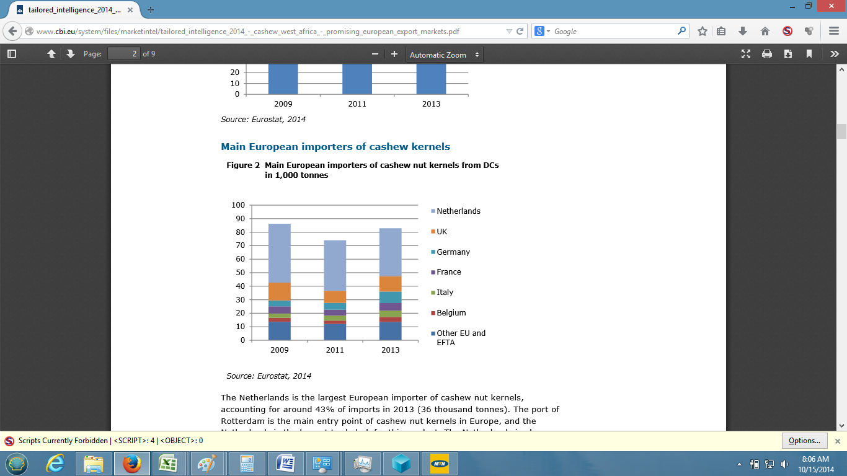

~~Over 80,000MT of cashew kernels were imported to European markets in 2013 from developing countries~~.

Plus de 80 000 tonnes d’amandes de cajou ont été importées sur les marchés européens en 2013 en provenance des pays en développement.

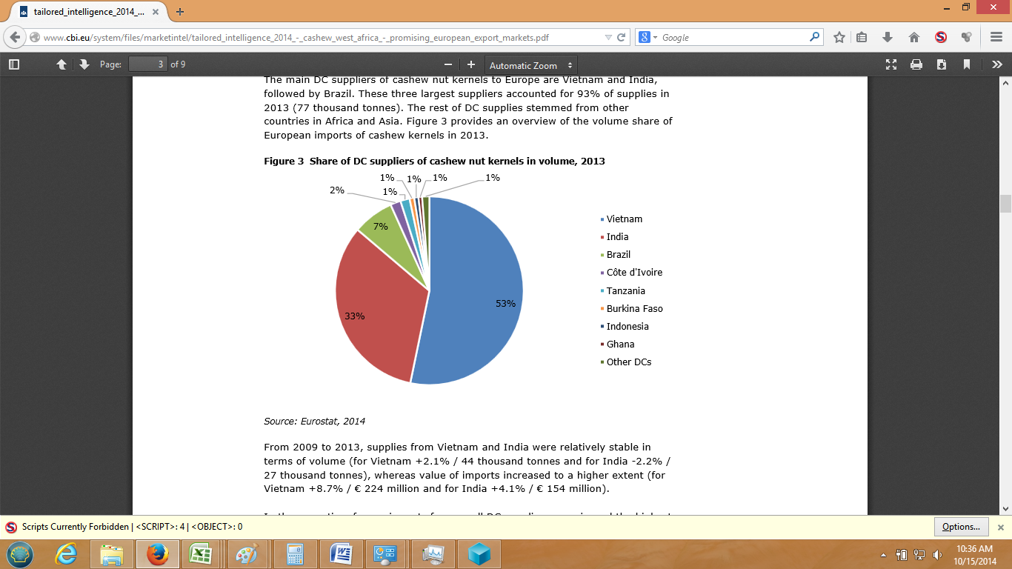

~~Of these kernel imports, 86% come from markets over twice the distance as Cote d'Ivoire (India and Viet Nam). Less than 10% of kernel imports come from Africa. However, of the kernels that do come from Africa. Over 30% come from Cote d'Ivoire. This is important to note because it suggests that kernels from the Cote d'Ivoire are already known and welcomed in European markets. Furthermore, the 2nd largest supplier from Africa to Europe is Tanzania, which is also further away than Cote D'Ivoire~~.

De ces importations d’amandes, 86% proviennent des marchés deux fois plus éloignés qu’un marché source comme delui de la Côted’Ivoire (l’Inde et le Vietnam). Moins de 10% des importations d’amandes viennent de l’Afrique. Cependant, de toute la production d’amande de cajou de l’Afrique, 30% proviennent de la Côte d’Ivoire. Il est important d le noter car cela montre que l’amande de cajou ivoirienne est déjà connue des marchés européens. Par ailleurs, le deuxième grand fournisseur africain d’amandes à l’Europe, la Tanzanie, se trouve aussi à une distance plus éloigée que la Côte d’Ivoire.

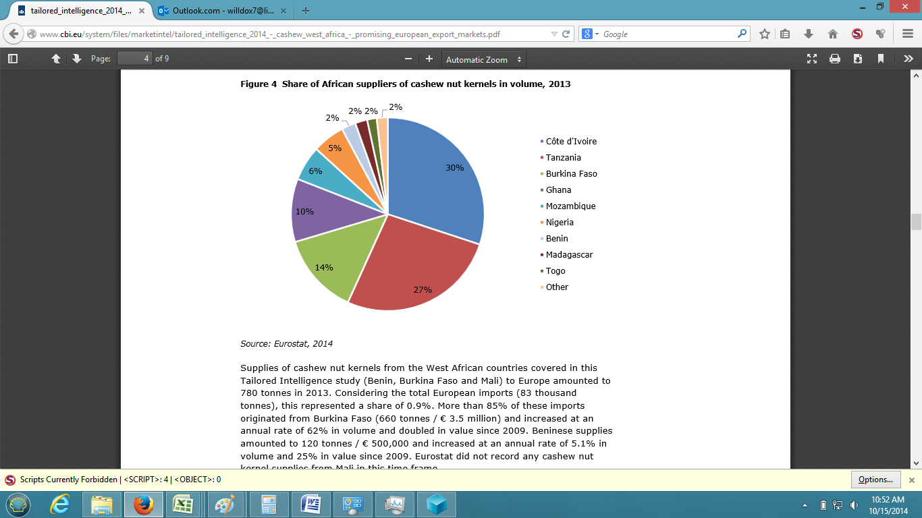

~~According to market study conducted by Pro Found - Advisers in Development from 2010-2013~~, ~~European demand consists mostly of whole cashew nut kernels for the rapidly growing snack market, whereas it is limited for pieces and splits~~. ~~Also, the most interesting European markets for African cashew kernels are the Netherlands, Belgium, the UK, Germany, France, Italy, Switzerland, Spain and the Scandinavian markets. In addition, these markets which are accustomed to importing their kernels mainly from India and Viet Nam, are increasingly sourcing their imports from African nations.~~

Selon une étude de marché conduit par Pro Found – Advisers in Development de 2010 à 2013, la demande européenne est essentiellement constituée de noix entières d’amandes pour le marché d’en-cas en pleine croissance. Les marchés européens les plus intéressants pour les produits africains sont les Pays – Bas, la Belgique, le Royaume – Uni, l’Allemagne, la France, l’Italie, la Suisse, l’Espagne et les marchés scandinaves. Ces marchés qui étaient habitués à l’importation de leurs amandes principalement de l’Inde et le Vietnam, s’approvisionnent de plus en plus auprès des nations africaines.

~~The market in the USA, in terms of sources is not that different from the European market. In 2013, the USA imported over 130,000MT of cashew kernels. Again, the largest suppliers being both India and Viet Name coming from a distance that is much farther away than the Cote d'Ivoire. Another notable statistic is that Brazil, despite its proximity, only exports a little over 9,000MT to the USA. Moreover almost 3,000MT are already imported from the Cote d'Ivoire. This suggests that the US markets are also already familiar with the Ivorian cashew kernels. From 2009 to 2013 the average growth rate of kernel imports has been 2%. As American consumers continuously seek out healthier snack items, companies who produce snack items increasingly depend on cashew kernels as a substitute. See the charts below.~~

Le marché aux Etats Unis d’Amérique (USA), en termes de sources n’est pas très different du marché européen. En 2013, les USA ont importé plus de 130 000 tonnes d’amandes de cajou. Les plus grands fournisseurs sont, à l’image de l’Europe, l’Inde et le Vietnam à une distance beacoup plus éloignée que celle de la Côte d’Ivoire. Une autre notable statistique est que le Brésil, malgré sa proximité, n’exporte qu’un peu plus de 9 000 tonnes aux USA. La Côte d’Ivoire quant à elle, exporte presque 3 000 tonnes de produits vers les USA.L’amande de cajou en provenance de la Côte d’Ivoire n’est donc pas npouvelle sur ce marché. De 2009 à 2013 le taux de croissance moyen des importations d’amandes a été de 2%. Puisque des consommateurs américains recherchent continuellement des produits d’en-cas plus sains, les entreprises qui les produisent devraient exploiter principalement l’amande de cajou.

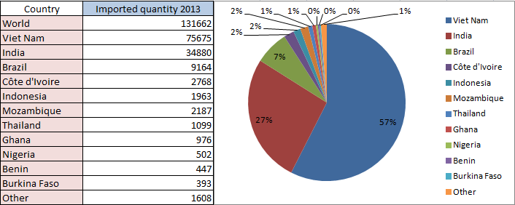

*Source: compiled from trademap.org, 2014*

~~Additionally, some of the largest purchasers of cashew kernels in the USA and Europe such as Caronut (USA, Spain), LB Nuts (Switzerland), Aldebaran Commodities (Netherlands), Trigon Nuts (UK) have indicated that they would prefer a product that has both a single origin and a significantly reduced carbon footprint than what is currently available. The environmentally and socially conscious consumer will prefer to purchase a cashew kernel that did not make the trip from West Africa to India and then back to Europe. They would rather purchase cashew kernels that of are a single origin, fully traceable and traveled the smallest distance in the shortest amount of time. In addition, the "African Success Story" is something western consumers are willing to pay for.~~

En outre, Certains des plus grands acheteurs d’amandes de cajou aux USA et en Europe tells que CARONUT (USA, Espagne), LB NUTS (Suisse), ALDEBARAN COMMODITIES (Hollande), TRIGON NUTS (Royaume-Uni) indiquent qu’ils prefereraient des produits d’une origine unique avec une reduction significative de la teneur en carbone par rapport aux produits disponibles sur les marchés actuels. Le consommateur écologiquement et socialement conscient préférera acheter des amandes de cajou qui ne proviennent pas de l'Afrique occidentale pour l’Europe en passant par l'Inde. Ils préfereraient acheter des amandes de cajou qui ont une origine unique et directe, transportées sur une distance et un temps relativement réduits. Les consommateurs occidentaux sont également enclins à payer pour l’”Histoire du Succès Africain”.

~~Based on the supply markets for RCN and the two largest demand markets for cashew kernels, it is obvious that there is a strong case to process cashews domestically in the Cote d'Ivoire. However it should also be noted that alternative markets for cashew kernels do exist and their growth rates greatly supplement the case for domestic processing.~~

En se basant sur les marchés de l’offre pour la noix de cajou brute et les deux gros marchés de la demande d’amande de cajou, il est evident qu’il y a fort intérêtà traiter les noix de cajou localement en Côte d’Ivoire. Nous pouvons cependant noter que des marchés alternatifs pour les amandes de cajou existent véritablement et leur taux de croissance évolue tout aussi rapidement.

|  |  |  |
| --- | --- | --- |
| **Pays** | **Quantité importée** | **Taux de croissance annuel en quantité 2009-2013 (%)** |
| Egypte | 123804 | 144 |
| Australie | 15794 | 3 |
| Canada | 11966 | 6 |
| Fédération Russe | 10044 | 13 |
| Japon | 8146 | 7 |
| Thaïlande | 7369 | 20 |
| Arabie Saoudite | 6909 | 11 |
| Liban | 3945 | 2 |
| Turquie | 3920 | 11 |
| Kazakhstan | 2843 | 37 |
| Taipei chinois | 2742 | 12 |

*Compiled from trademap.org*

~~Lastly, the industry has only recently become mechanized, the reason for this being that cutting open raw cashew nuts is a delicate process and broken kernels fetch a substantially lower price than wholes. In recent years, the machines have been fined tuned to break less cashews, minimizing broken kernels as a result of the production process.~~ ~~This technological advance in machinery has been coupled with a strong Indian demand for broken pieces (used for gravies, sauces and desserts), narrowing the price gap between whole kernels and broken pieces~~. ~~Currently, the Indian government has banned the importation of cashew kernels, broken or whole. Traders therefore label broken pieces as "pig feed" or some other kind of feed to get around this.~~

Cette industrie a été récemment mécanisée car, décortiquer la noix brute de cajouest un processus assez délicat et les amandes cassées se vendent à un prix nettement inférieur à celui des amandes entières. Ces dernières années, les machines ont été finement réglées pour casser moins de noix de cajou, et minimizer le taux de brisures à la fin du processus de production. A cette avancée technologique s’ajoute une forte demande indienne de pieces cassées (utilisées pour les sauces et les desserts), ce qui réduit considérablement la différence de prix. Actuellement, le gouvernement indien a interdit l’importation des amandes de cajou cassées ou entières. Pour contourner cette mesure, les commerçants étiquettent les pièces cassées comme "alimentation de porc" ou comme d’autres types d'alimentation.

~~Overall there are many reasons why processing cashews domestically appears to be attractive. The main reasons from the points above are as follows:~~

~~a. The largest processing countries do not produce enough raw material to meet their processing demand. This adds additional cost and uncertainty into the industry.~~

~~b. The two largest markets for cashew kernels source over 80% of their supply from a considerably longer distance than the Cote d'Ivoire, cutting down on time in transit will help the securing of contracts.~~

~~c. Cashew kernels from the Cote d'Ivoire are already well known in the largest importing markets. This suggests less capital and resources will be needed establish product awareness.~~

~~d. The demand for cashew kernels is growing and growth is projected to remain strong, both in the EU and USA, as well as the alternative markets. This true even for broken pieces. Suggesting that almost all that is produced will be sold at a reasonably profitable price.~~

~~e. As environmentally and socially conscious companies seek out single origin, fully traceable kernels that aren't too far away, they will increasingly look to Cote d'Ivoire for cashew kernels.~~

f~~. Technological advances have minimized the percentage of broken kernels and minimized the worker's exposure to the skin irritants in the cashew shell.~~

En définitive, il y a plusieurs raisons pour lesquelles traiter les noix de cajou brute en Côte d’Ivoire a un intérêt particulier. Les raisons principals sont les suivantes :

1. Les plus grands pays de traitement ne produisent pas assez de matière première pour satisfaire leur demande de traitement.
2. Les deux plus grands marchés d’amande de cajou s’approvisionnent pour plus de 80 % à une distance considérablement plus longue que la Côte d'Ivoire
3. Les amandes de cajou de la Côte d'Ivoire sont déjà bien connues sur les plus grands marchés d'importation. Moins de ressources seront nécessaires pour le lancement du produit.
4. La demande d’amandes de cajou grandit et la croissance devrait demeurer forte, tant dans l'UE que les USA, et aussi bien dans les marchés alternatifs. Cela est vrai même pour les amandes cassées. Ce qui laisse entrevoir que toutes les productions devraient être vendues à des prix relativement intéressants.
5. Pour les acheteurs dotés d’une conscience écologique et environnementale, La Côte d’Ivoire est le lieu d’approvisionnement idéal eu égard à la distance, cela par rapport aux autres régions de production.
6. Les avancées technologiques minimisent le pourcentage de graines cassées et l'exposition des travailleurs aux irritants de peau contenus dans la coque dure de la noix de cajou, lorsqu’ils sont en contact avec le produits.

C. Contraintes possible pour la transformation du cajou

~~Processing raw cashew nuts into kernels is quite a tricky task. Above all when you are in West Africa. There are a number of things that can go wrong and turn a very profitable activity into losing adventure. Below, some of the biggest risks will be presented and how S3C plans to mitigate them.~~

La transformation de noix de cajou brute en amandes est une tâche très delicate. Surtout lorsque l’on est en Afrique occidentale. Il existe un certain nombre de facteurs qui peuvent retourner la situation d’une activité rentable à l’origine en une véritable catastrophe financière. Nous présentons ci-dessous quelques risques auxquels est exposéel’activité et comment la STNC entend les atténuer.

1. L’incapacité d’obtenir la matière première.

~~This is a relatively small risk in the Cote D'Ivoire, simply because of the ration of production to processing capacity. In 2015, 600,000MT of raw cashew is expecting to be produced, while only 80,000MT processing capacity is available in the country~~. ~~Also, just because the capacity is there does not mean that it is utilized. In fact, it is estimated that only 60,000MT-65,000MT will be processed in 2015~~. ~~S3C's plan to mitigate this risk:~~

~~S3C already has experience in procuring cashew, and plans to export about 20,000MT in 2015, therefore if S3C procures the same proportion of Cote D'Ivoire's crop in 2016, 2017, 2018 etc., they will not have a problem~~. ~~The key will be to select top quality raw material~~.

C’est un risque négligeable en Côte d’Ivoire, simplementà cause de la part de la capacité totale de transformation dans la production annuelle de noix brute. En 2015, la prévision de production de cajou brut est évaluée à 600 000 tonnes, alors que les capacités de transformation du pays s’élèvent à 80 000 tonnes et elles ne sont pas forcément pleinement mises en oeuvre. En fait les estimations de transformation en 2015 sont évaluées seulement entre 60 000 Tonnes et 65 000 tonnes.

Le plan de la STNC pour attenuer ce risque :

Les promoteurs de la STNC ont déjà une experience avérée dans le secteur et prévoient exporter environ 20 000 tonnes en 2015. Si les approvisionnements évoluent dans les mêmes proportions que les prévisions de récolte du pays en 2016, 2017, 2018 etc., il ne devrait pas y avoir de problème. La veritable clé sera de choisir la meilleure qualité de matière première.

2. Localisation éloignée de la main d’oeuvre et du service technique.

~~This is quite a large risk considering how labor intensive cashew processing is~~. ~~The risk is also present when advanced technology will be used. If you are located far from the population and technicians, labor problems and machine problems are likely to arise.~~

Ce risque est significatif quand on considère l’importance de la main d’oeuvre nécessaire pour le traitement des noix de cajou brutes. Le risque est aussi present lorsqu’une technologie avancée. Si l’usine est implantée loin de la population et des techniciens, des problèmes de main d’oeuvre ou des pannes techniques peuvent surgir.

~~S3C's plan to mitigate this risk:~~

~~S3C plans to situate the plant in the Yamoussoukro area. Experts have differing opinions about this location, and there are pros and cons. These are:~~

~~a. Cons:~~

~~i. Not located in a heavy cashew producing area ii. Zone B, only 8 years of exonerations. iii. Transportation costs will be higher because of the transportation of raw cashew.~~

~~b. Pros:~~

~~i. Located next to labor and easy access to Abidjan for technical assistance. ii. Relatively desirable for foreign laborers. iii. Stable power and other utilities. iv. Located in the center of the RCN trade. We can select the highest quality RCN from all regions without being limited to one area. v. A technical school is being built, that is to be specialized in training for cashew processing.~~

Le plan de la STNC pour attenuer ce risque :

La société envisage s’installer dans la zone de Yamoussoukro. Les experts ont des avis différents sur cet emplacement :

a. Contre:

i. Non située dans une region productrice de noix de cajou ii. Zone B, seulement 8 années d’exonération. iii. Les coûts de transport seront plus élevés à cause du transport des noix brutes de cajou.

b. Pour:

i. Situation géographique proche de la main d’oeuvre et accès facile à Abidjan pour l’assistance technique

ii. Situation géographique desirable pour les travailleurs expatriés. iii. Fourniture d’électricité stable et autres commodités. iv. Située au carrefour du commerce de noix de cajou brutes. Nous avons la possibilité de choisir la meilleure qualité de noix de cajou brute de toutes les régions sans être limités par l’une quelconque .

v. Une école technique est en construction à Yamoussoukro. Elle sera spécialisée dans la formation aux métiers de la transformation de la noix de cajou.

~~These are just some of the pros and cons, but the pros outweigh the cons for the type of processing plant proposed. In addition S3C plans to petition for Zone C treatment, extending the exonerations to 15 years.~~

Ce sont quelques argumentations pour des avis divergents. Pour le type d’usine propose, les avis favorables prennent l’avantage sur les avis défavorables. En plus, la STNC envisage demander un traitement de faveur pour bénéficier des exonerations de la zone C.

3. Absence d’assistance technique et de connaissance du processus de transformation. (Problème materiel et problème de qualité)

~~Many investors like the attractive margins advertised by the current market conditions~~. ~~One thing that is always overlooked is how complicated the process is and how many different ways the machines can be a problem~~. ~~In many cases, it is not actually the machines or the process where the problem lies, but in the management of these two important factors.~~

Beaucoup d’investisseurs sont attires par les marges intéressantes annoncées par les conditions actuelles du marché. Cependant les éléments qui sont toujours négligés sont la grande complication du processus et les multiples difficultés que l’on pourrait rencontrer à l’utilisation du materiel et outillage industriel. Dans bien des cas, les problèmes ne sont pas directement liés aux machines ou au processus de production, mais plutôt à la gestion de ces deux importants facteurs.

Le plan de la STNC pour attenuer ce risque :

~~For technical assistance, S3C plans to hire a qualified expatriate who is specialized in mechanical and electrical engineering to be on location. This individual(s) will travel to the machine manufactures' sites and train with them until S3C is satisfied with the acquired knowledge.~~

Pour l’assistance technique,la STNC envisage de recruter un expatrié qualifié spécialisé dans l’ingénierie mécanique et électrique et qui demereurera sur le site. Cet agent se rendra chez les fournisseurs de machine pour recevoir la formation et la connaissance adéquate au benefice de la STNC.

~~For the machines, S3C's contracts with the manufactures will require some form of maintenance agreement, a guarantee of promoted performance and longevity. When possible, S3C will insist that the technicians of these companies stay a minimum of 3 months at the site to remedy any problems that may immediately arise.~~

Pour l’acquisition des machines, les contrats liant la STNC au fournisseurs prévoiront une clause de maintenance, une clause garantie de la performance et de la longévité du materiel. A l’installation, la STNC insistera pour que les techniciens de ces entreprises demeurent sur le site pendant au moins 3 mois afin de rémédier à tous les problèmes qui pourraient immédiatement surgir.

~~For the production management, S3C plans to hire an expert from the cashew production industry to ensure that the production is perfected~~. ~~This person will know which step of the process is performing sub-par and will know which parameters to adjust to improve the production process. In addition this person will have knowledge concerning the raw material, proper handling and storage.~~

Pour la gestion de la production, la STNC envisage d’engager un expert de l’industrie de transformation de cajou pour assurer une bonne production. Cette personne saura quelle étape du processus est défectueuse et quells sont les paramètres à ajuster pour améliorer le processus de production. Cette personne aura des connaissances dansle traitement et le stockage des matières premières.

**In addition the specific risk minimizations in this area, S3C also plans to reduce overall risk, by processing a small amount in the months leading up to a "full production" attempt. This will be crucial in perfecting the production process and the path of the product from start to finish.**

4. la vente d’amandes cassées.

~~Selling the broken pieces at a profitable price will be difficult. Currently, the largest market and best prices for pieces is in India, however the government has placed a ban on the importation of pieces~~. ~~As stated earlier this ban can be circumvented, however, with the correct planning and handling of these pieces the Indian market is not necessary~~. ~~This study considers that 35% of the production will be in pieces. Some factories create less and some create more. However assuming that 35% will be pieces and that they will sell at the international prices is the most accurate approach.~~

La vente de pieces cassées à un prix profitable sera difficile. Actuellement, le plus grand marché etles meilleurs prix de pieces se trouvent en Inde, cependant le gouvernement a interdit l’importation des pieces. Comme exposé plus tôt cette interdiction peut être contournée, cependant, avec une correcte planification et le traitement de ces pièces le marché indien n'est pas nécessaire. Cette étude considère que 35% de la production totale seront en pieces. Cette estimation est la plus plausible bien que certaines usines créent moins de pieces et d’autres beacoup plus.

Le plan de la STNC pour attenuer ce risque

~~The machines that have been selected, have the lowest breakage rates. The plan is to use the machines exactly how they are supposed to be used and carry out proper preparation of the raw material and maintenance on the machines to maximize the performance~~. ~~The current collection of machines have about a 23% breakage rate when calculated as a total. This rate was calculated by adding the highest promoted broken rate from each machine in the process and adding an additional 1% for each handling step~~. ~~So to mitigate the selling of the piece S3C has chosen to minimize the broken rate.~~

Les machines qui ont été sélectionnées ont les taux de rupture les plus bas. Les machines seront utilisées exactement comme elles sont supposées l’être. Une preparation appropriée des matières premières et la maintenance des machines seront effectuées pour maximiser la performance. La collection actuelle de machines a un taux de rupture d’environ 23% au total. Ce taux a été calculé en y ajoutant le plus haut taux de rupture pour chaque machine dans le process et en ajoutant un taux additionnel de 1% pour chaque étape de stockage. Ainsi, pour maîtriser ce risqué la S3C a choisi de minimizer le taux de rupture.

In addition, a cubing process will be used for the pieces that are not "butts" or "splits." This process chops the pieces into homogenous sizes. Food manufactures have indicated that they prefer a standard size when they buy pieces. Industry insiders have stated that Indian piece sizing machines are not accurate enough for the food industry. Therefore the cubing process will enable customers to create custom orders based on their exact needs.

Par ailleurs, un processus de decoupage en cube sera utilisé pour les prièces en morceaux ou fendues. Ce processus tranche les pieces tranche les pieces dans des tailles homogènes. Les promoteurs d’industries agro-alimentaires indiquent qu’ils préfèrent une taille standard à l’chat des pieces. Les initiés d'industrie ont déclaré que les machines de classement par taille de morceau indiennes ne sont pas assez précises pour l'industrie alimentaire. Et donc le processus de decoupage

5. Underestimating labor needs and labor's productivity

Many investors do not realize how labor intensive cashew processing is. Even with automatic shelling machines and peeling machines, there are still steps in the process that machines are not capable of performing in their entirety, this includes: sorting shelled cashew, peeling (after the pealing machine), and sorting defective kernels. This requirement is often underestimated by everyone in the industry and relies heavily on the labor's experience and performance of the machinery. S3C's plan to mitigate this risk:

First and foremost, S3C has hand selected the machinery to ensure that productivity will be high and labor requirements will be manageable. The labor assumptions are based on advice from industry experts and statistics provided by the machines in question. Both by the manufactures and by the users. Furthermore the study includes additional labor needs that have not yet been defined, but have simply been assumed as needed. None the less, if labor is underestimated, the factory is located in an area where it will not be a problem to take on additional labor on relatively short notice.

6. Shells, Testa, CNSL

An additional risk when processing cashew is not knowing what to do with the empty shells. If the oil is extracted from the shells, the problem becomes not knowing what to do with the oil. The testa is also considered waste and needs to be dealt with. S3C's plan to mitigate this risk:

S3C plans to extract the oil from the shells, burn the remaining solids to power the boiler and collect the CNSL. CNSL can be exported and sold locally to the paint and cement industry. The testa will be sold as cattle feed. The clients will need to be developed further as income from the CNSL is assumed in the financial analysis.

7. Changes in the market; price and demand.

The most unpredictable risk is the market place. Some factors can be assumed. For example, consumers are become more health oriented, they are also becoming more socially and environmentally conscious about how they spend their money. However, nobody knows what the prices are going to be in the future, analysts and experts can only speculate based on historical data, geopolitical events and climate trends. These three factors can pose a threat to the cashew industry not only in Cote D'Ivoire and for S3C, but to processors all around the world. S3C's plan to mitigate this risk:

In a way the risk as already been mitigated by the choice to process in West Africa. On one hand, according to climate change studies, the Cote D'Ivoire will only become more suitable to growing cashew in the future. And although Cote D'Ivoire has not been the most politically stable country in the recent years and the situation can become quite volatile quite fast, Cote D'Ivoire is on the world stage and is surging past its neighbors to become the economic powerhouse it once was. On the other hand, historical data suggests that price stability creates demand growth in the industry, this demand increasingly coming from socially and environmentally conscious consumers. When prices rise sharply, demand growth becomes very sluggish. S3C's plan to sustain growth in either of these situations is to build a processing plant that is compliant with food safety regulations and suitable work conditions in the facility. This coupled with efficient management should ensure that when demand grows or if prices rise sharply, S3C and their clients are the beneficiaries.

D. Introduction to the Process

The process of transforming cashews from the raw nut attached to the bottom of the apple into the white kernel that ready to eat is quite lengthy. The process differs slightly from region to region but overall, the general work flow is as follows:

**2. Cleaning and Calibrating the RCN**

**1. Sun Drying the Raw Cashew Nuts**

**7. Grading by color and size**

**8. Packaging**

**6. Peeling**

**5. Preparation for Peeling**

**4. Shell removal and separation**

**3. Steaming/Roasting, CNSL extraction**

Next, each process will examined in depth.

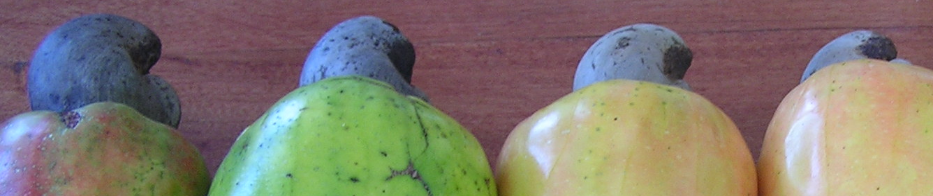

**1. Sun Drying the Raw Cashew Nuts**

This process is self-explanatory. This step is only required at the plant if it is not carried out before arriving. It is recommended that the RCN be brought to around 8% humidity as soon as possible to reduce the risk of deterioration while in storage. In addition processing raw cashews at a moisture level higher than 8% will greatly reduce the quality of the output.

**2. Cleaning and Calibrating the RCN**

First dust and foreign material are removed from the RCN. Then based on the machine, the RCN are sorted into 4 to 8 sizes. The main purpose of sorting the nuts is to make sure that they are processed by a machine that has been appropriately adjusted. Washing the nuts in a water bath is especially important if the cooking method is the CNSL bath, because sand can contaminate the oil and build up at the bottom, making it harder to clean.

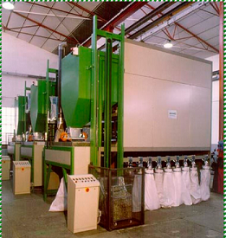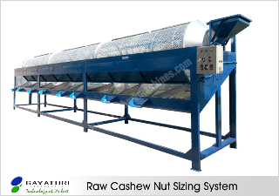Oltremare.

**3. Steaming/Roasting, CNSL extraction**

The previous two steps are more or less standardized. However the purpose of this step is to heat up or cook the shell, both making it easier to remove and in some cases to extract the CNSL. This process varies from factory to factory, but there are three main methods used. All three methods will be discussed as they have little implication on the following steps. The first is the rotary drum steaming. The nuts are heated with steam to a high temperature in a rotating drum. After, the nuts are collected and cooled before shelling. The second process is the oil bath roasting method. In this method, the nuts bathed in hot CNSL, which releases the CNSL from shells. This softens the shell, then during the drying the shell becomes brittle and easy to crack. The third method is the steaming method. This usually consists of an autoclave that cooks the nuts under pressure. Most west African processors use the autoclave as it proves effective for processing smaller quantities.

VietMold (Viet Nam). Rotary autoclave Oltremare oil bath roaster.

.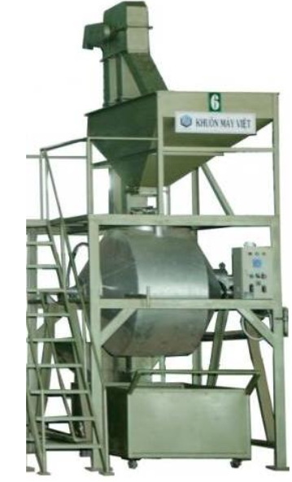 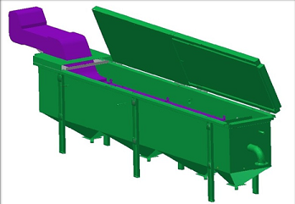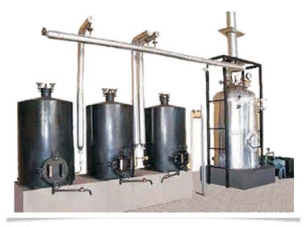 Indian autoclave method

**4. Shell removal and separation**

This is arguably the most important step in the transformation process. Traditionally this laborious step is a manual process, and many processors in India maintain this method. The main reason for this is because the mechanization of this step resulted in relatively high percent of broken kernels, lowering the value of the production. However in recent years, Indian technology has advanced and the machines have become efficient concerning broken kernels. The only drawback of the Indian machines is that they usually have a lower processing capacity which (depending on the total amount of RCN processed) requires more machines and labor compared to other methods. Moreover, the price of labor in India is relatively low, enabling Indian processors the continue processing RCN manually. In Brazil, the industry is highly mechanized however the percentage of broken kernels is also relatively high (estimated at 40-45%). The process is called impact or percussion shelling. Where the nuts are launched against a hard surface, cracking the shell open. As the Brazilians process such a large volume, they are able to sustain the higher rate of broken kernels, but with government intervention is industry, this is changing. The situation is different for Vietnamese processors. Due to the higher labor costs and relatively low production of RCN, they are forced to optimize their machines to minimize the percentage of broken kernels and process higher volumes with less labor. Most the Indian and Vietnamese shelling machines share the same technology with regards to the mechanics of the shelling. The Indian machines cut vertically and the Vietnamese cut horizontally. Indian's usually stop at 4 cutting heads per unit, while the Vietnamese will reach 8 cutting heads. Oltremare is an Italian firm that has also contributed significantly to the mechanization of this process. The Oltremare production process require a minimal amount of manual labor, but demands a technically skilled staff. Oltremare shelling machines operate on a mechanized principle of the manual process in brazil. The nut is held in place on one side, while a blade penetrates the shell then rotates from the other side to pry the shell open.

The output from the shelling machines usually consists of: kernels, shells, uncut and partially cut nuts and "to be scooped" or "kernel in shell." Therefore, a separation method is usually attached to the shelling section. The design of these lines varies widely from factory to factory no matter what country the processing plant is in. For example, some factories in India have women who sit at the outlet of each shelling machine separating the output. Some have shelling machines that discharge all parts onto a perforated vibrating table to separate the kernels from the rest. In Vietnam, most mechanized shelling machines have a separation unit, that consists of a process to physically remove the kernels from the have stayed in the shells while separating the rest onto conveyor tables that sorted through by humans. Oltremare is particularly advanced in this area. After the nuts are shells the kernels are separated with a vibrating table, which also shakes additional kernels loose from their shells. At the same time, the line separates the uncut shells and automatically recycle them back to shelling machines. At the end of the line, Oltremare proposes electronic color sorters, to sort the rest of the material to make sure that no shells or fragments continue on to the following process. The objective of immediate separation is to avoid contaminating the kernel with CNSL from the shell.

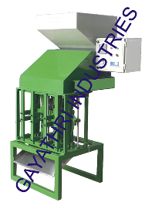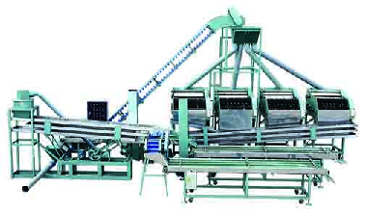

Indian Shelling machine 40Kg/h Cao Thanh Shelling/Separation line 400kg/hour

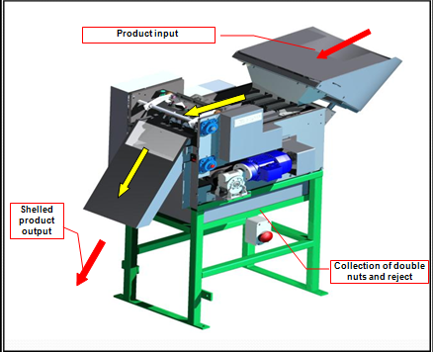

Oltremare Shelling Machine

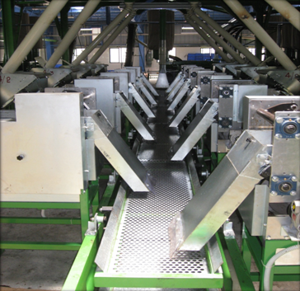

Oltremare Shelling and separation line (11 machines)



**5. Preparation for Peeling**

After the RCN has been shelled and the kernel has been separated, the kernel is covered by thin reddish-brown layer of skin called the testa. The testa is removed before consumption. In the manual process, the shelled kernels were peeled by rubbing the kernels between one's fingers and then using metal or bamboo peeling knives to finish the process. However, for the mechanized peeling process, the kernels are loaded on to trays and stacked in trolleys and cooked for around 7-8 hours in large ovens or "bormas." This makes the testa brittle and easy to remove. After the oven, the kernels go through a re-humidification process which makes the kernels less brittle reducing the broken rate in the peeling machine. In India, most processors use water vapor at room temperature, while in Vietnam processors mostly use steam for re-humidification. The Indians claim that using steam causes the kernel's quality to degrade the Vietnamese claim that it doesn't matter but there is a risk of over steaming, causing the color from the skin to stain the kernel. The difference of a opinion stems from the fact that the Indian consumer is more picky about their cashews than the international market. Oltremare offers a continuous method for both drying and re-humidification, reducing the number of people required for the entire process, while also reducing the number of components to achieve the same objective.

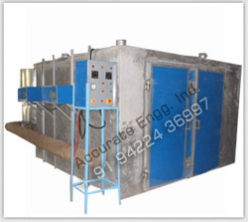 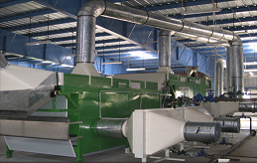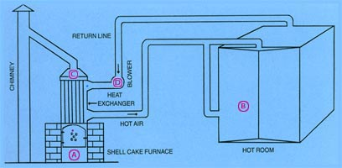Accurate Eng Borma 1MT capacity. Oltremare continuous dryer. ABHAY Shell fueled dryer (concept)



**6. Peeling**

After the kernels have been properly prepared, the peeling process involves the actual removing of the testa from the kernels. The manual process was mentioned above. However the mechanized process is very different. Most of the peeling machines available on the market function more or less in the same way. The kernels with the testa attached, enter a rotating tunnel to crack the testa, then the kernels enter a chamber where compressed air is used to "blast" the testa off of the kernel. After the kernel is peeled, the testa is typically diverted into a collection reservoir. The end of the process usually contains a sorting section to separate pieces from whole kernels. Then after that, it is common to see a conveyer table with 10-20 persons for manual separation of peeled and unpeeled kernels. One drawback of peeling machines is that they may result in additional broken kernels, reducing the value of the output. In addition, the air compressor component demands a high amount of electricity. Although most peeling machines have a high processing capacity, they typically do not achieve a 100% peel rate. As a result, the kernels must return to the machine for a second time or be peeled manually. All mechanical peeling machines are derived from the original Oltremare design.

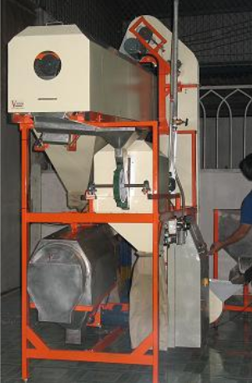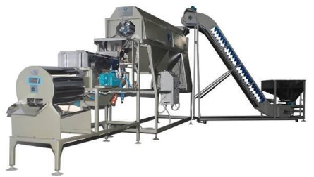

Viscon Peeler

Vietmold Peeler

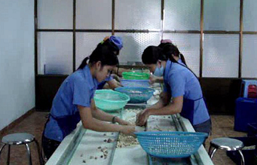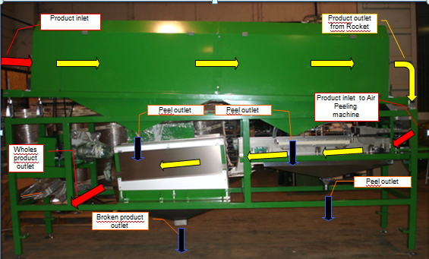  
 Oltremare Peeler Typical conveyor table from peeler output

**7. Grading by color and size**

Once the kernels have been fully peeled, they need to be sorted by color and graded by size. In the manual process, the sorting lines sort by color, size, whole/broken and characteristics. In some factories, machines have been programmed to sort both by color and size, while in other factories the broken pieces are separated from the wholes, then each are sorted by size and color by hand. In addition they are small capacity graders. The more industrial approach is to have two color sorting machines, one for whole kernels and for pieces. These color sorters sort by the "accept and reject" principal. Therefore, of the all the kernels passed through color sorter, the accepted kernels are white with no defects. The rejected kernels will consist of scorched, spotted, unpeeled and partially peeled kernels. Currently, there is not a machine available that sorts all of defected kernels and these have to be dealt with manually. There are mechanical grading machines, but these machines grade by width and not volume or length, which results in inaccurate grading. Oltremare offers an electronic grading machine that grades cashew with extreme accuracy and at high capacities. Although an international standard for classification has emerged, most factories can choose to sort and package however they desire. There are typically 26 grades that are traded internationally, and not every classification method is the same. According to AFI standards,

"Cashew kernels are classified as: First Quality Fancy; Second Quality Scorched; Lightly Blemished Wholes (LBW), Blemished Wholes (BW), Third Quality Special Scorched, Fourth Quality, and Dessert. Where:

FIRST QUALITY FANCY: cashew kernels have a uniform color which may be white, light yellow or pale ivory.

SECOND QUALITY SCORCHED: cashew kernels may be yellow, light brown, light ivory, light ash-grey or deep ivory.

THIRD QUALITY SPECIAL SCORCHED: cashew kernels may be deep yellow, brown, amber, and light to deep blue. They may be slightly shriveled, immature, light-brown speckled, blemished or otherwise discolored.

FOURTH QUALITY: cashew kernels would qualify as First or Second Quality, except that they have pitted spots.

Lightly Blemished Wholes (LBW): cashew kernels may be light brown, light ivory, light ash-

grey or deep ivory. Kernels may show light brown speckles or blemishes on the surface,

provided that not more than 40 percent of the kernels are affected.

Lightly Blemished Pieces (LP): cashew pieces may be light brown, light ivory, light ash-grey or deep ivory. Pieces may show light brown speckles or blemishes on the surface, provided that not more than 20 percent of the pieces are affected.

Blemished Wholes (BW): cashew kernels may be deep yellow, brown, amber or light to deep blue. Kernels may be slightly shriveled, immature or may be brown speckled or blemished on the surface, provided that not more than 60 percent of the kernels are affected.

DESSERT: cashew kernels may be scraped, deeply scorched, shriveled, deep-brown-speckled, black-speckled, blemished or otherwise discolored.

Furthermore, sizing of the cashews is mandatory for the first quality/fancy, but optional for lower grades. The sizing standards are as follows:

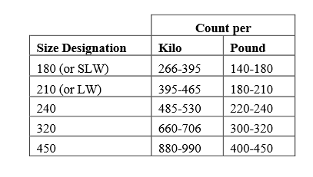

Although these are the standards for importing into the USA, markets in India have other classes for domestic distribution. In addition to the afore mentioned sizes, Indian markets also have W500 with a corresponding nut count per pound. W400 can be found as well, along with a long list of classification for pieces. The Cashew Export Promotion Council of India Supplies a visual guide for the different grades of cashews: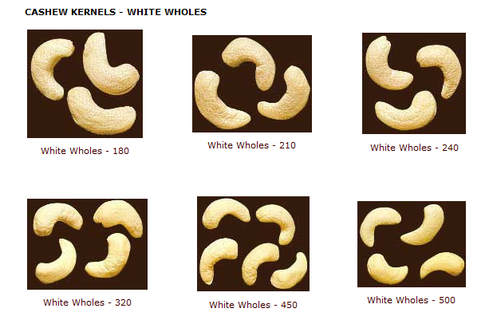

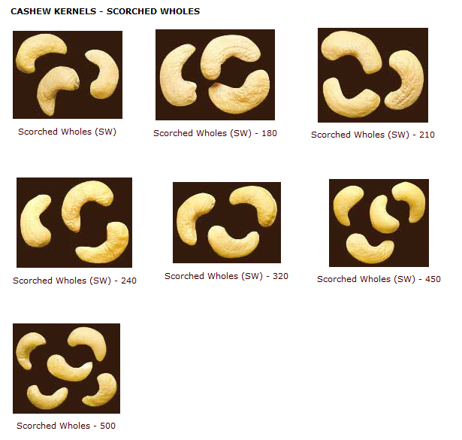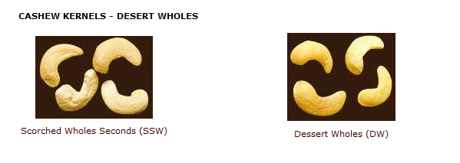

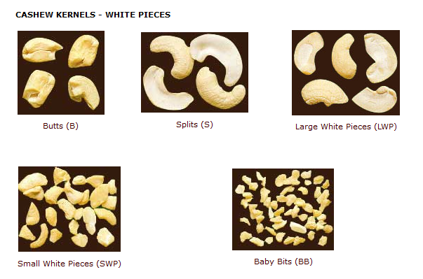

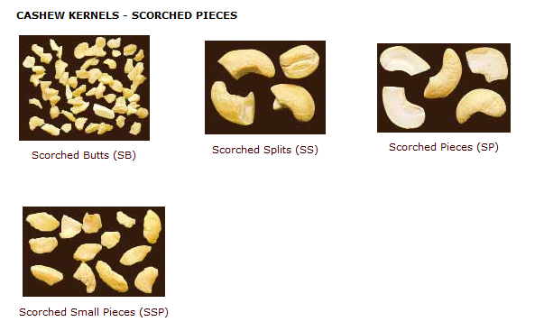

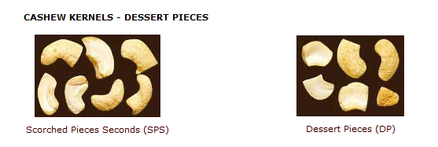

The definitions of "Scorched" and "Dessert" remain the same as those defined by the AFI. Note that "SLW" (Super Large Whole) is the Brazilian equivalent to W180 and "LW" (Large Whole) is equivalent to W210.

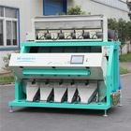 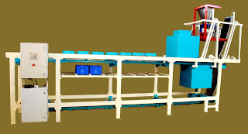 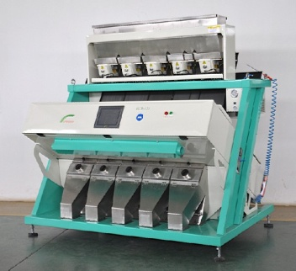

Taiho Color Sorter Nanopix Color/Size sorter Shangai Huanxin

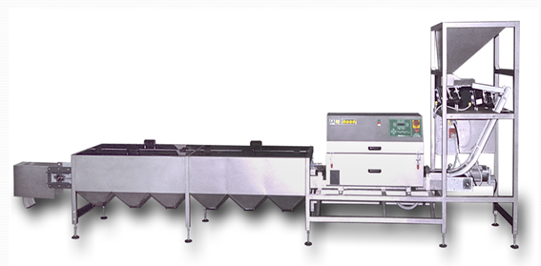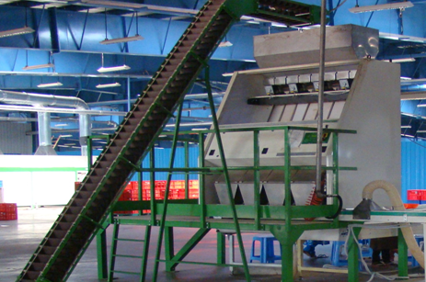

Oltremare Grading Line (Falko) Oltremare color sorting line (LUX)



**8. Packaging**

After the kernels have been sorted by color and size, some factories pass the kernels through an x-ray scanner to detect and remove any foreign matter such as: metal, hair and dust. Other factories also pass the kernels through a UV sterilization machine to prevent any microbial growth. These two processes ensure the high quality product and provide the highest level of food safety. For factories that consist of a high level of human contact (manually grading and sizing) a UV sterilization tunnel is recommended. After the preventive food quality measures have been taken, the kernels are ready to be packed. The is to have a packaging machine that deposits the kernels into the exportable packaging and weighs it. The same machine typically will vacuum seal the container while simultaneously injecting an inert gas into the bag to prevent infestation. This is usually a food grade CO2 or nitrogen based gas. The kernels are packaged into 25lbs or 50lbs plastic bags and sealed in new cardboard boxes. Some factories package in aluminum tins however this is mainly for the domestic market. The international market's preference is for the plastic "flexi-pack."

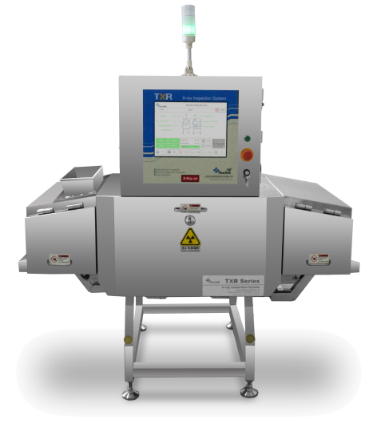 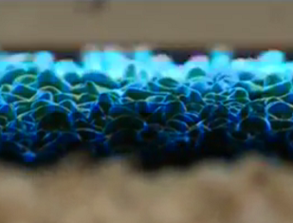

Technik x-ray Scanner Screen of x-ray scanner UV sterilization tunnel.

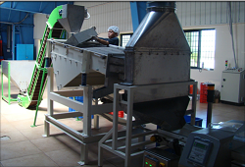 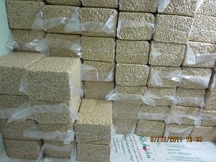

Oltremare packaging line Flexi-pack plastic bags

Other important aspects of processing cashew that are rarely included in the process are CNSL extraction and the boiler. In India and Vietnam it is not very common to see a cashew processing plant that also extracts the CNSL. These factories usually collect their shells and sell them to CNSL extraction plants. Planning to process 10,000 -30,000 tons of cashew in Cote D'Ivoire must also be accompanied by a plan to process the shells. There is simply not enough demand for cashew shells locally. The boiler is the part of the plant that creates the steam to supply the steam to the cookers and re-humidification sections and can also supply any other thermal energy requirement. In India and Vietnam, these boilers are often fueled by wood and cashew shells that have been purchased back from CNSL extraction plants. The plan for Cote D'Ivoire is to process the cashews, extract the oil from the shells and then use the shells to fuel the boilers. Reducing environmental degradation and avoiding the hazard of disposing of the cashew shells.



E. Review and Comparison of Machinery

As mentioned above, the three main cashew processors are India, Brazil, and Vietnam. Therefore it is no surprise that this is where the technological advances have taken place. On the other hand, the most advanced technology and present in all three countries is Oltremare of Italy. A noticeable difference between the technologies lies in their level of industrialism. The Indian machines are the least industrial. The shelling machines in India are mostly copies of a Sri Lankan company called Buddhi Industries. The design of the machine consists of a small loading hopper and two vertical shafts that contain two blades each. The nuts are forced down the shaft and are pushed passed the two blades, cutting it on each side. The results of these machines depend mostly on how well the nuts were calibrated (sized) and well the machines are calibrated (distance between the blades) to cut that specific size. Some factories in India don't even calibrate the nuts before shelling. However, when the nuts are well calibrated a 95% rate for whole kernels in achievable, even for extra small and extra large nuts. There are over 50 cashew shelling machine manufactures in India and almost every machine follows the principle. Another indicator of the artisanal nature of the Indian process is the size of the autoclave typical Indian auto claves have a 60kg-320kg per batch capacity, requiring an enumeration of machines to achieve a high input. Among other things, Indian processors usually use a lot of labor to recuperate kernels. Many sort baby bits, carve out defective parts of kernels and grade kernels by hand. In a country like Cote d'Ivoire, the amount of production time and money spent on labor would be more than the value of salvaged kernels on the export market. Overall most processing units in India process about 1,200 to 3,000MT raw cashew nuts per year. This is not to say that there are not factories that process large amounts. Rajkumar Impex has multiple 30,000MT+ factories in India, but most of the machinery does not come from India. Vietnam's cashew industry is more industrial than India's, however machine manufactures still operate mostly in "batch" mode. While they process higher quantities per year, there still a lot of manual handling. The calibrators in Vietnam usually handle 1-1.5MT per hour compared to 250-500kg per hour from Indian manufactures. Likewise, the steam cooking process usually handles upwards to 1MT per batch. The shelling machines employ the same cutting principle as the Indian machines, however the difference is that the Vietnamese machines move the nuts horizontally with a continuous chain. Moreover, Vietnamese manufacturers usually situate 6-8 cutting heads side by side in each cutting machine and usually situate 4 cutting machines side by side, giving you 32 cutting heads per unit. This cutting unit is followed by various methods of separation attached. Consisting of an aspiration unit for shells, centrifugal chambers for separating kernels that are stuck in the shell, along with sorting tables for the output to be inspected by the human eye. The results is a larger processing capacity and a large reduction in labor. The remaining uncut nuts are largely processed manually. The drying process like in India is the typical tray/trolley/dryer system where the kernels are loaded on trays and put in shelved trolleys to be dried for 7-8 hours. The same trolleys are used for the re-humidification process. Some factories in Vietnam have a somewhat continuous peeling system. For example at Coa Phat Co., Kernels are loaded into peeling machines and the output is directly fed to a color sorter which are then taken to be graded by hand. In Brazil the industry is mixed. According to the ACA, most Brazilian processors fabricate some of their machinery and import some as well. According Stefano Massari, DG of Oltremare, the Brazilian method mainly consists of CNSL bath roasting to make the shells brittle, then impact shelling. A process where the cooked nuts are launched against a hard surface to break shell and separate the kernel. This method is not viable for West Africa as it causes a high percentage of broken kernels which substantially lowers the value of the output. Also in Brazil, after the kernels have had a pass through the peeling machine, the unpeeled kernels are then outsourced to groups of people to peel. This could an interesting method in Ivory Coast as a larger number of people will be required to perform this task. Overall, it can be concluded that the pure Indian method of processing is not suitable for 15,000MT per year. Although the maintenance of the machines is less, the number of machines to maintain and the labor required for the manual aspects of the process would render the plant unmanageable and financially not feasible. The Vietnamese approach could be feasible for 15,000MT per year. However the process is not continuous and the shelling while processing larger quantities of raw nuts, may still require a large amount of manual work. This is with the exception of the Viscon machines, which achieves an uncut percentage of 6% as well as a broken percentage of 6%. The most industrial process available on the market is from Oltremare. The turnkey plant from Oltremare is a mostly continuous operation, operating for 21 hours of the day, 6 days of the week. There are substantial drawbacks to the Oltremare concept. The first being the price. European designed equipment comes with a European price tag. In addition, for the shelling section to be as effective as possible it is highly recommended that the CNSL oil bath be the method for cooking the raw nuts. This requires that the nuts be washed well before entering the bath, as well as draining the oil from the bath once a week to be cleaned. Also, if the parameters are not strictly respected, the risk for scorching the kernel is high. The shelling section also has a large number of moving parts and is mechanically advanced. This could pose a problem for technical assistance if a machine stops functioning correctly. However there is a lot conceptually that must be adopted from the Oltremare process. The majority of Vietnamese and Indian processors cool the raw cashews after steaming on the ground and overnight. This requires both time and space. Oltremare uses perforated storage silos which achieves the same objective, however labor is not required to spread the nuts out and recollect them the next day. The silo is simply filled at the top with a capacity of 1 and 1 half days of supply, and emptied at the bottom, so by the time the nuts travel from the top to the bottom, they are ready to be shelled. The next aspect that should be taken from the Oltremare process is the continuous dryer and re-humidification system for the kernels. This will keep the process continuous, while reducing labor and reducing confusion that could arise in the batch method. Lastly, the Oltremare peeling, grading and sorting system should be employed. However, instead of the Italian color sorters which are vertical sorters, more inexpensive horizontal color sorters should be used.

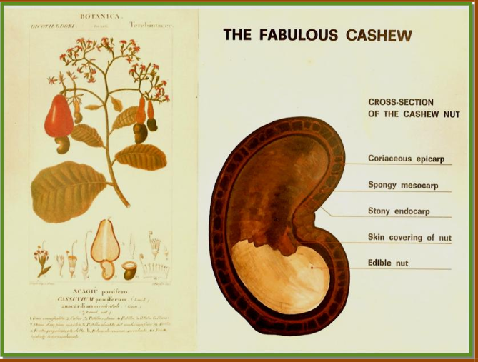

F. Machinery to be Used

(based of 15,000MT/Year, may vary in financial analysis/final purchase)

1. Boiler - Coa Phat Co. - 2x - $60.000 ~ XOF 30.600.000 FOB HCMC

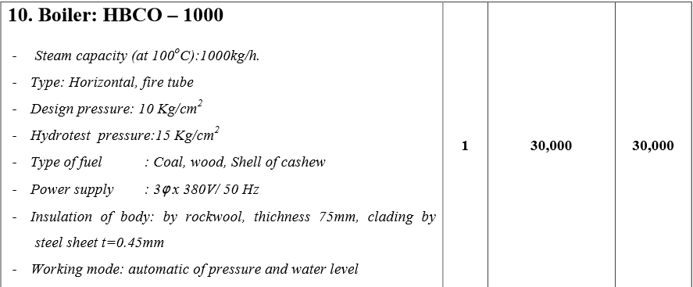

Two boilers at smaller capacities would be a better option than one large boiler. If one is malfunctioning the other can be used still without a complete halt in production. This is the price from a Vietnamese supplier. If this can be obtained locally, it should be. This way a warranty is easier to exercise. It will be fueled at first by firewood, then as shells become available they will be used. The piping will be supplied locally.

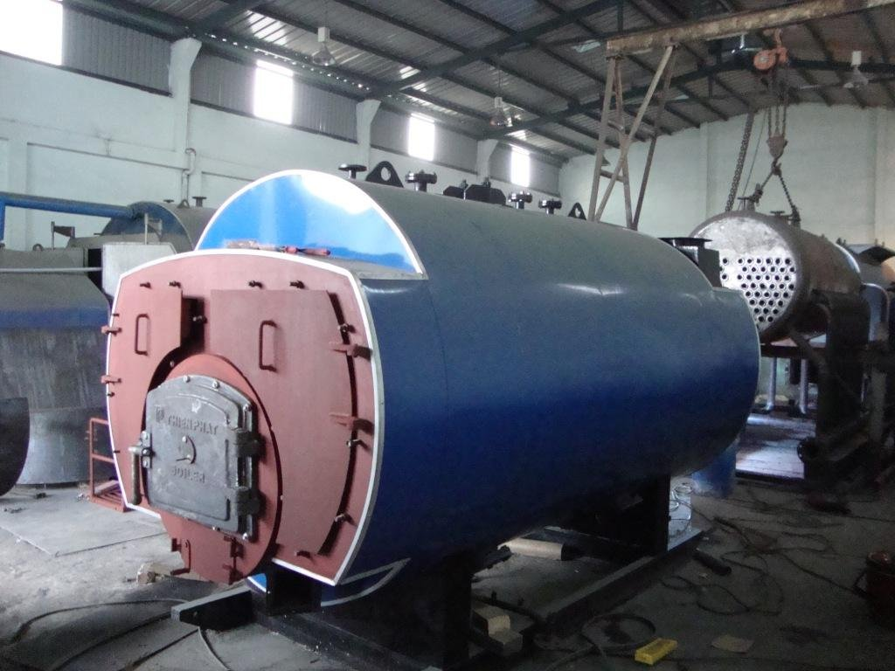

2. RCN Grading Machine - Viscon - 4x - $90,000 ~ XOF 45.900.000 FOB HCMC

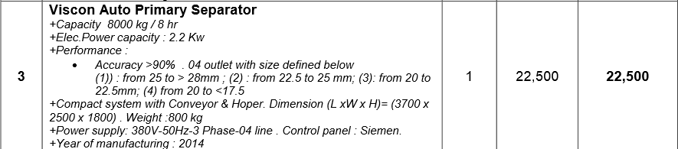

This machine was chosen to match the shellers. 4 machines will have an output of 4 tons per hour which more than sufficient for 15,000MT per year. In addition, this grading machine has a perforated cylinder that is slightly thicker than the other suppliers, making it more accurate when sizing raw cashews, rendering the shelling more efficient. In addition, the manufacturer has agreed to modify the output of the nuts. The original design has nuts exiting on both sides. This would complicate the handling. Therefore it will be modified so that the nuts all exit on one side. The handling will be sourced locally.

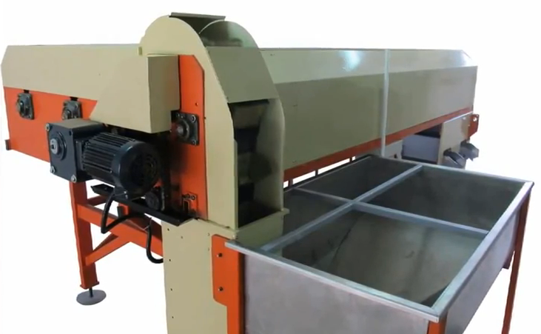

3. Steam Cooker - Cao Phat Co. - 2x - $20,000 - XOF 20.400.000 FOB HCMC

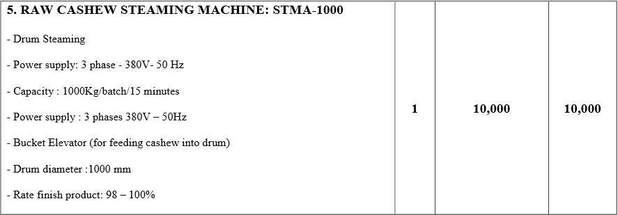

These steamers are inexpensive and durable. 1 MT per batch at 15 minutes will translate to 3 MT an hour. Two will be sufficient. These units include the bucket elevator. From the output, the nuts will be unloaded into perforated silos for cooling. In India and Vietnam, the cooked nuts are spread on the ground, this will require too much space for this production level. Each batch will be the same size and will be organized that way. The hoppers will then be emptied to feed the shelling section. The silos can be fabricated locally with the Oltremare design.

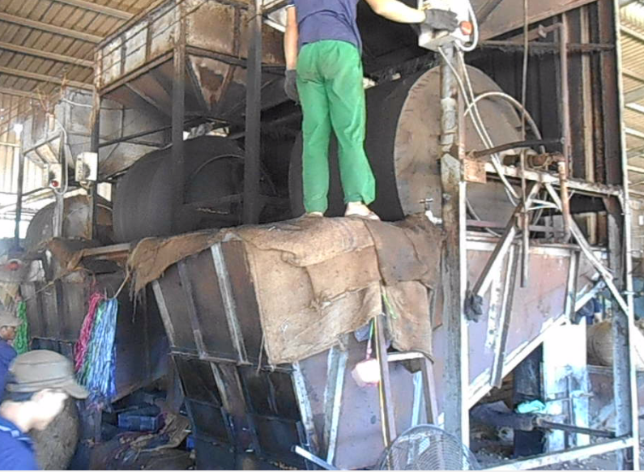

4. Shelling Section - Viscon - 17x - $824,500 - XOF 420.495.000 FOB HCMC

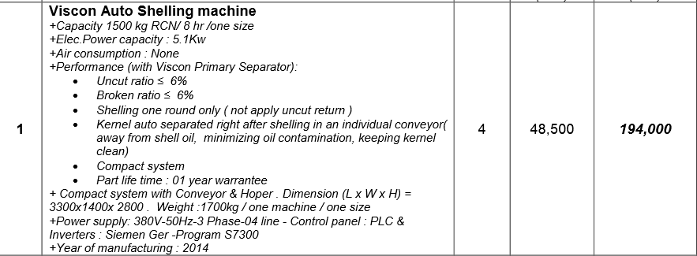

This machine was chosen because of its efficiency. The 6% uncut and 6% broken is unmatched at this capacity. In addition the manufacturer agreed that 30% of the payment can be held until these numbers are achieved. These shelling machines will only attempt to cut nuts that are sized correctly. This reduces the rate of shelling, but also decreases the number of broken kernels. There are 4 sizes, A, B, C and D. The distribution of the machines will be 3xA, 6xB, 6xC and 2xD. This may change depending on the distribution of nut sizes found in Cote d'Ivoire however based on 2013, this should be accurate. The rejected nuts will be sent to Indian cutting machines that have been sized to cut nuts smaller than 18mm and larger than 28mm. According to the distribution of raw nut sizes (Vietnam, of mixed origin) less than 5 percent of the nuts should be smaller than 18mm and the same for nuts larger than 28mm. Therefore about 20 Indian shelling machines will also be used and adjusted to cut these sizes. Automating the handling in the section will be done locally, dimensions will be defined at a later date.

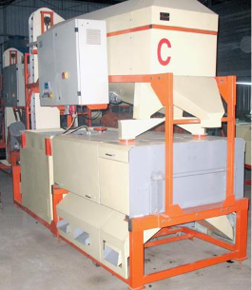

5. Indian Shellers - 20x - Best Eng - $63,800 - XOF 32.538.000 - Ex Works Hyderabad - or - Small (Size D) Cao Phat Sheller - $45,000 - FOB HCMC

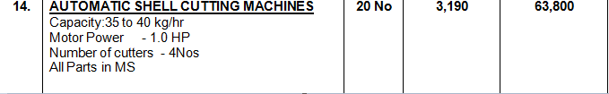

These machines we chosen because of the standard design and precise fabrication. In addition, Best Engineering is partnered with CDT of Cote d'Ivoire so if we need maintenance it will be a quicker response. Furthermore, 20 machines will process 700kgs of raw nuts per hour, this is 22% of our production requirements. If a Vietnamese machine breaks, these machines can be easily adjust to shells the desired size of production. A vibrating table will accompany this line, with a kernels collection tray. The kernels will join the kernel output of the Vietnamese machines and the shells will join the other outputs. The handling will be sourced locally. These machines are claimed to produce 87-90% whole kernels, 3-5% splits and butts and 10% uncut. Therefore, 6% left over from the 3,125 Kgs (50TPD at 16 hours) per hour from the Vietnamese machines is 187.5 kgs. This leaves 512.5 kgs/hour of capacity for uncut, under/over sized nuts and slack capacity if a Vietnamese machines malfunctions.

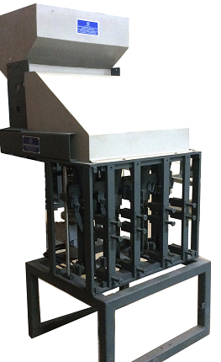

6. Sorting Lines - Best Eng - 10x - $72,850 XOF - 8.815.350 Ex works Hyderabad

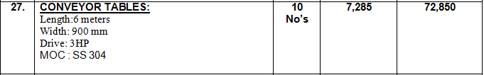

These lines will be for the uncut, kernels, shells and shells with kernels remaining. They will be fed from the cutting machines. The handling to the tables will be sourced locally.

7. Super Calibrator - Oltremare - 3x - €36,820 - XOF 24.153.920 ex works Bolo



As the kernels move the shelling area to the drying area, they should be separated into whole and pieces. The reason for this separation before peeling is so that there is less breaking of the whole nuts in the peeling machine. Handling to the peeling section will be sourced locally

8. Drying, Re-humidifcation - €462.490 - XOF 303.393.440 ex works bolo







 At this point the plant will operate on three 7 hour shifts as opposed to two 8 hour shifts. The drying system is an expensive system. The reason why Oltremare was chosen for this project is because it is a continuous system and runs for 21 hours a day. In addition, there is less room for human error. In the traditional drying methods humans are responsible for transporting the kernels on trays and trolley from the shelling area to the drying are and then also to the re-humidification section. The conventional dryers take about 6-8 hours to the dry the kernels and then 5 minutes to 2 hours to re-humidify the kernels. The capacities range from 1-2 tons. Therefore it would be a non-continuous out of kernels and everything would be ran in batches. These dryers cost around $10,000-$12,000 a dryer, around 8 dryers would be recommended in order to keep the flow of production. In between the dryer and re-humidification steps the kernels are required to cool for a few hours. The re-humidification rooms can cost $5,000 a piece. The trays and trolleys cost around $3,000 and at least 20 trolley/tray sets would be required. Although the trolley system would be substantially less expensive, the timing would be less precise and a higher risk for scorched kernels is present.

10. Peeling section - Oltremare - €454.610 - XOF 298.224.160 Ex works Bolo















Again the system is quite expensive, but well worth it. Also, the kernels will passed twice through the peeling machines. The color sorters can be obtained at a less expensive price. Re-peeling, sorting and grading are the most labor intensive aspects of this processing plant. According to a study in Tanzania(the only African country with data), manual peeling rates are about 1.25 kgs per hour. Processing 15,000 tons will result in about 528kgs/hour or (6,930,000lbs/year) of kernels for 21 hours of production this would require about 423 people per shift or 1,268 total(salaries worth XOF 1.293.360.000 per year). The peeling machines generate both unpeeled kernels and kernels with "testa adhering", the difference is "testa adhering is usually less than 2% of testa which is accepted as peeled in the market. Assuming a lower performance in the peeling machine about 22% will not be peeled. This would result in 116.16 kgs of unpeeled kernels per hour, requiring 93 workers per shift or 279 workers total (salaries of 284.580.000 per year). However running this 116.16 kgs/hour through the peeling machine a second time would result in 25.55 kgs unpeeled, requiring only 21 workers per shift, or 63 workers total (salaries of XOF 64.260.000 per year). It must be noted that the productivity of the peeling machine has its drawbacks. Most peeling machines give a range of 6-12% broken kernels per pass. Considering a safe estimate of 10% broken from the shelling section an additional 1% from the other stages, this could result in up to 23% broken pieces after the first pass through the peeling machine(23% is larger than the mathematical calculation as 10% are already broken, therefore only 90% of the whole kernels should be considered "breakable," however for this planning it is more prudent to consider lower performance and improve from that). Assuming 12% are broken from the peeling and that these kernels would have been the average W320 at an average retail FOB price of $3.35/lb, this equals 831,600 lbs of the yearly production which equals $2,785,860. However these kernels are now splits/butts/pieces which will sell at an average price of $2.66/lb, totaling $2,212,056. The difference is a loss of $573,804 or XOF 292.640.040. The second pass of the unpeeled kernels will result in a breakage rate of 18% as the kernels are more vulnerable. Of the 116.16kg per hour that are not peeled, 21kgs/hour will be broken. At 21 h/day for 300 days/year, this equals 291,060 lbs per year. For WW320 this equals $975,051 per year, these now sell at $2.66 for $774,219.6 for a loss of $200,831.4 or XOF 102.424.014. However the labor reduction from 279 to 63 represents salaries of XOF 220.320.000 per year.

To summarize, the machines in this section represent a reduction in labor from 1,268 to 63 workers and 5 technicians a year. It also represents a reduction in value of 1,122,660 lbs of product. However the reduction in labor saves about $2,409,036 or XOF 1,229,100,000, while the reduction in value of product is around $775,000 or XOF 395.073.054. With the depreciation of the section calculated at 20% of XOF 58,107,168, this brings the overall cost of the peeling section to XOF 453.180.222, representing a total savings of XOF 840.179.778 or about $1,647,000 a year compared to a manual process. The same calculations hold for sorting and grading as they require more labor and the machines are less expensive. It is important to note that this section could require an additional 150 workers to sort through the rejected kernels (to removed spotted, stained or contaminated kernels) an additional XOF 153.000.000. The handling of the kernels will be sourced locally.

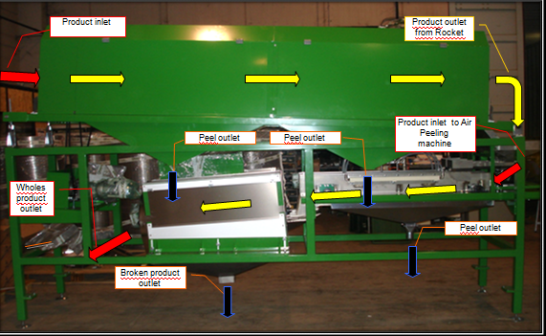

11. Piece Grading - Best Engin - 5x - $9,525 - XOF 4.857.750 Ex works Hyderabad

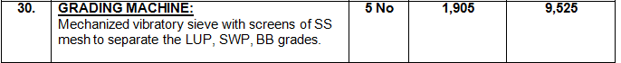

12. Packing Line - Vietmold - $45,000 - XOF 23,001,000 FOB HCMC

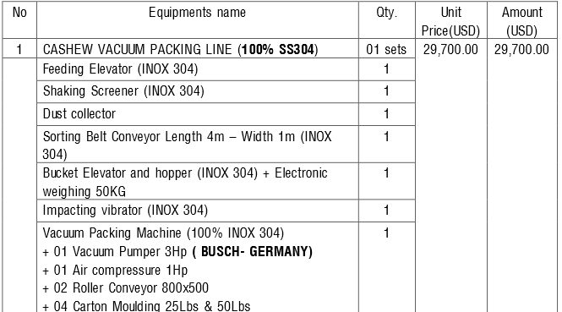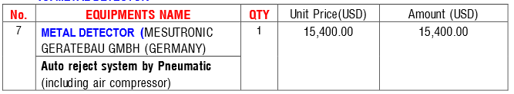

This machine will be acquired from Viet Nam for quality/price reasons. It is mostly automated, including a shaking screen and vacuum packing machine separated by a metal detector for one last quality check. The Oltremare system is almost identical but costs about €116.000. The Indian systems are less expensive, but not inclusive of all components.

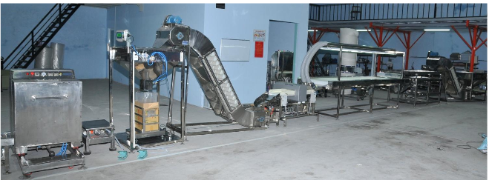

12. Air Compressor - 4x - $93,300 - XOF 47.583.000 FOB HCMC

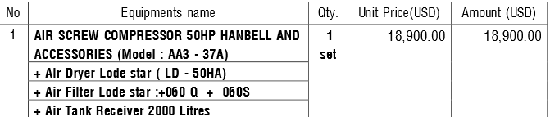

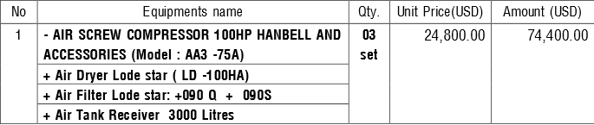

These air compressors are suggest by the suppliers. In reality, these could be sourced locally or elsewhere to save on cost and perhaps obtain warranty. The actual needs of the plant will be determined by the engineers. Compressed air is required for aspiration systems, the peeling machines, grading machines and color sorting machines.

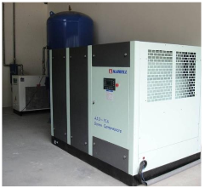

13. Optional Equipment - $28,550 - XOF 14.560.500 ex works Hyderabad

|  |  |  |
| --- | --- | --- |
| **S.NO** | **DESCRIPTION** | **QTY** |
| 1. | **PLASTIC CRATES:** | 100 No’s |
| 2. | **PEELING KNIFES:** | 30 No’s |
| 3. | **Pouch Packing Machine:**  **(50 – 250 grams)** | 1 No |
| 4. | **Electronic Weighing Scale:** | 1 No |
| 5. | **Grading & Peeling Tables:**  **(S.S.304 Top & M.S frame)** | 10 No’s |
| 6. | **Stools for Grading & Peeling Tables:** | 20 No’s |
| 7. | **Moisture Meter:** | 1 No |
| 8. | **Scooping Tool:** | 50 No’s |

14. Other material - Locally sourced, to be determined by construction. Allowance of $300,000 - XOF 153.000.000.

Included

-Steam pipers

-Additional Handling

-Perforated Silos

15. Summary of Equipment and additional things to consider.

Machine Costs-

|  |  |  |  |
| --- | --- | --- | --- |
| Section | Company | Country | Price XOF |
| Calibrage | Viscon | Vietnam | XOF 45,900,000.00 |
| Cuisson | Cao Phat | Vietnam | XOF 45,900,000.00 |
| Stockage | Local | Local | XOF 122,400,000.00 |
| Decorticage | Viscon/Abhay | Vietnam/India | XOF 504,903,600.00 |
| Separation d'amandes | Oltremare | Italy | XOF 24,153,920.00 |
| Sechage/rehumidifcation | Oltremare | Italy | XOF 303,393,440.00 |
| Depeliculage/Triage | Oltremare | Italy | XOF 258,060,160.00 |
| Emballage | Vietmold | Vietnam | XOF 23,001,000.00 |
| Compresseur | Vietmold | Vietnam | XOF 47,583,000.00 |
| Autres | Local | Local | XOF 166,897,500.00 |
| Expellers | TBD | TBD | XOF 30,600,000.00 |
| Option | Best Engin | India | XOF 14,560,500.00 |
| Total |  |  | XOF 1,587,353,120.00 |

~~This list comprises the minimum machines necessary to effectively transform at least 3.125 MT/hour of raw cashew nuts into kernels. The peeling section will process around 750kgs an hour. Processing 6 days a week, 15,000MT per year will be achieved. Note that this does not include the price of erection and other commissioning charges. Those costs will be reviewed in the financial section of this report.~~

Cette liste comprend les machines minimales nécessaires pour transformer efficacement au moins 3,125 MT / heure de noix de cajou brutes en amandes. La section depeliculage traitera autour de 750kgs / heure. Traitement 6 jours par semaine, 15,000MT par an sera atteint. Notez que cela ne comprend pas le prix de l'érection et autres frais de mise en service. Ces coûts seront examinés dans la section financière du présent rapport.

Other Things to Consider

a. Pre-grading Stage.

~~Raw cashews nuts should be dried in the sun light or an appropriate dryer to a moisture level of 7.5% before stocking and processing. Depending on the location of the plant this could pose a challenge, as the main harvesting season in the north coincides with the rainy season in the south. Processing cashew nuts at a high humidity will almost always guarantee a lower quality of output in the kernel.~~

Les noix de noix de cajou brutes doivent être séchées à la lumière du soleil ou un sèche appropriée à un niveau de 7,5% de l'humidité avant le stockage et le traitement. Selon l'emplacement de l'usine que cela pourrait poser un défi, comme la principale saison de récolte dans le nord coïncide avec la saison des pluies dans le sud. Traitement des noix de cajou à une humidité élevée sera presque toujours garantir une qualité de sortie dans les amandes.

~~Also during the grading/stocking stage, it is recommended to have a system to clean the nuts. In a given lot of raw cashew, a certain percentage will be empty nuts, the plantation owners cannot do anything about that. However there are a few methods that plantation owners use to take advantage of independent verification companies. Some plantations will roll the nuts in sand to increase the weight of a lot, others will not always remove the remaining tip of the apple that adheres to the nut.~~ ~~Failing to remove this material or failing to negotiate an appropriate price for this raw material will cause a loss in production volume and overpayment of raw material. It also could deteriorate the efficiency of the machines. To remove the empty nuts before processing, there are aspiration systems or a simple float test is effective as well(soaking the nuts in water and removing the floating nuts). The problem with the float test is that additional drying is required. Making sure that the moisture level is low and the outturn of the raw material is the most important step for successful processing.~~

Également, au cours de la phase de classement / stockage, il est recommandé d'avoir un système pour nettoyer les noix. Dans un lot donné de cajou brutes, un certain pourcentage sera coques vides, les propriétaires de plantations ne peuvent rien faire à ce sujet. Cependant, il existe quelques méthodes que les propriétaires de plantations utilisent pour profiter de sociétés de vérification indépendantes. Certaines plantations vont rouler les noix dans le sable pour augmenter le poids d'un lot, d'autres ne seront pas toujours retirer la pointe restante de la pomme qui adhère à la noix.

Négliger d'enlever ce matériau ou de ne pas négocier un prix approprié pour cette matière première va causer une perte du volume de production et de paiement excédentaire de la matière première. Il pourrait également se détériorer l'efficacité des machines. Pour enlever les coques vides avant le traitement, il existe des systèmes d'aspiration ou d'un test de flotteur est efficace aussi bien (tremper les noix dans l'eau et enlever les noix flottants). Le problème avec le test de flotteur est que le séchage supplémentaire est nécessaire. Se assurer que le niveau d'humidité est faible et le résultat de la matière première est l'étape la plus importante pour la réussite du traitement.

b. Grading

~~Proper grading is a key step that must be taken to ensure the productivity of the cutting machines. The more accurate the grading of the raw nut the better performance of the cutting machines. This is because most machines are most effective when they have been calibrated to cut within a range of 2 mm. Otherwise some nuts get cut too deep and some nuts aren't cut enough, resulting in either broken kernels or uncut nuts that will require additional manual labor.~~

Le calibrage est une étape essentielle qui doivent être prises pour assurer la productivité des machines de decorticage. La plus précise le classement de la noix cru, la meilleure performance des machines de decorticage. Ceci est parce que la plupart des machines sont les plus efficaces quand ils ont été calibrés pour couper dans une gamme de 2 mm. Sinon quelques noix se couper trop profond et quelques noix sont pas coupées assez, résultant soit dans les grains cassés ou des noix non coupées qui nécessiteront un travail manuel supplémentaire.

c. Steaming

~~Once the nuts have been properly graded and separated, the next step is to steam the nuts. Since the nuts are already separated, they should be steamed with nuts of the same size. Each size may need a slightly different steaming time. Larger nuts may take a few seconds longer than small nuts. Usually nuts are steamed from between 15-20 minutes, depending on shell thickness and size. Lastly, there is a water purifier in the list of machines. This is important for the steamers, so they don't build up a residue of calcium and other "hard" elements.~~

Une fois que les noix ont été correctement classés et séparés, la prochaine étape est de faire cuire les noix avec de la vapeur. Puisque les noix sont déjà séparés, ils doivent être cuits à la vapeur avec des noix de la même taille. Chaque taille peut avoir besoin d'un temps de vapeur légèrement différente. Grandes noix peuvent prendre quelques secondes de plus que les petites noix. Habituellement, noix sont cuits à la vapeur entre 15-20 minutes, selon l'épaisseur de la coque et de la taille. Enfin, il existe un purificateur d'eau dans la liste des machines. Ceci est important pour les autoclaves, afin qu'ils n'accumulent pas un résidu de calcium et d'autres éléments "durs".

d. Cooling

~~After the nuts have been steamed, the shell is soft and the size of the nut has increased slightly. The kernel and testa inside is still full of moisture. Therefore these nuts need to be dried. In India most factories spread the steamed nuts out on the ground to cool overnight (not in direct sunlight). Some factories in Viet Nam, simply repackage the nuts back into the jute sacs from which they came. The proposal for this project is to use large perforated silos. There are a few reasons. First, it is more sanitary than spreading the nuts on the floor. Second, spreading nuts on the floor requires a large open space.~~ ~~Third, perforated silos will reduce the number of labors. Instead of labor spreading the nuts on the floor and picking them back up or filling and stacking jute sacs, the nuts will exit the steamers and be directly lifted into the silos. The silos' capacities will be determined at a later date. However preliminary recommendations would be have a number of silos dedicated to each size of nut, these silos could be stocked over night and~~ then emptied in the morning for shelling. ~~A second recommendation would be to have 4 large silos dedicated to each size, with a capacity of a 75 tons, this way by the time the nuts that were placed at the top made it to the bottom, they would have sufficient time to cool. One drawback of the later plan would be that if production stopped down the line, the steaming section could also be halted. While overall labor will be reduced with this system, slightly more competent labor will be required to keep track of what product is where.~~

Après que les noix ont été cuits à la vapeur, la coque est doux et la taille de la noix a légèrement augmenté. Le amande et l'intérieur Testa est encore en plein d'humidité. Par conséquent, ces noix doivent être séchés. En Inde, la plupart des usines réparties les noix à la vapeur par terre pour refroidir toute la nuit. Certaines usines au Viet Nam, reconditionnent simplement les noix de retour dans les sacs de jute d'où ils proviennent. La proposition de ce projet est d'utiliser de grands silos perforées. Il ya quelques raisons. Tout d'abord, il est plus hygiénique que de répartir les noix par terre. Deuxièmement, l'étalement des noix par terre nécessite un grand espace ouvert. Troisièmement, les silos perforées vont réduire le nombre de travailleurs. Au lieu que le travailleurs verses les noix par terre et les ramasser à remplir et à empiler des sacs de jute, les noix vont quitter les autoclaves et seront directement soulevée dans les silos. Les capacités des silos seront déterminés à une date ultérieure. Cependant, les recommandations préliminaires seraient a un certain nombre de silos dédiés à chaque taille de noix, ces silos pourrait être stocké pendant la nuit et ensuite vidé dans la matinée pour le décorticage. Une deuxième recommandation est d'avoir quatre grands silos dédiés à chaque taille, d'une capacité de 75 tonnes a, de cette façon par le temps les noix qui ont été placés au sommet sont arrivés au fond, ils auraient suffisamment de temps pour refroidir. Un inconvénient du ce plan serait que si la production arrête plus tôt dans la ligne, la section de la vapeur pourrait également être arrêtée. Bien que la main-d'œuvre globale sera réduite avec ce système, des travailleurs un peu plus compétente seront tenus pour suivre la production.

~~e. Shelling~~

e. Décorticage

~~The shelling line proposed for the project will be effective. As follows from the step before, the nuts will be optimally sized and steamed to maximize the performance of the shelling machines. First the nuts will be processed in Vietnamese shelling machines. These machines separate shells, kernels, uncut nuts and nuts with the kernel still attached to the shell, however all of these outputs will discharge on to respective conveyors to be sorted through manually. This will avoid loss of product and prevent shells and other material from entering the kernel treatment area. The uncut nuts will mostly consist of nuts that are either too large or too small to cut, these nuts will be either manually or automatically loaded into a different Vietnamese shelling machine.~~

La ligne de décorticage proposé pour le projet sera efficace. Comme il ressort de l'étape précédente, les noix seront dimensionnés de façon optimale et cuit à la vapeur afin de maximiser la performance des machines de décorticage. D'abord, les noix seront traitées dans les machines de décorticage vietnamiens. Ces machines séparent coques, amandes, les noix et les noix non coupés avec l'amande toujours attachée à la coques, mais toutes ces extrants vont se décharger sur les convoyeurs respectifs d'être triés manuellement. Cela permettra d'éviter la perte de produit et empêcher des coques et d'autres matières d'entrer dans la zone de traitement d'amandes. Les noix non coupées consisteront principalement de noix qui sont soit trop grand ou trop petit pour couper, ces noix seront soit manuellement ou automatiquement chargées dans un autre décortiqueuse vietnamien.

f. Preparation for peeling - Drying and re-humidification

~~The purpose of this stage is to ensure that the skin can be easily removed from the kernel and that the kernel does not break in the peeling machine. During the trial runs, this section will be one of the most important to keep track of in order to perfect the parameters for optimal results. The Indian and Vietnamese methods require more labor and therefore inherently possess more room for error. The proposal for this project is a continuous system equipped with the water purifier so as to not clog the re-humidification lines and possible contaminate the kernels with elemental residue.~~

Le but de cette étape est de veiller à ce que la peau peut être facilement retiré du amande et que l'amande ne se brise pas dans la machine de depeliculage. Pendant les courses d'essai, cette section sera l'un des plus important de suivre afin de parfaire les paramètres pour des résultats optimaux. Les méthodes indiens et vietnamiens exigent beaucoup de travailleurs et donc possèdent intrinsèquement plus de place pour l'erreur. La proposition de ce projet est un système continu équipé du purificateur d'eau afin de ne pas obstruer les lignes re-humidification et possible de contaminer les grains avec résidu élémentaire.

g. Peeling-Grading-Sorting

~~After drying and re-humidification, the kernels will be ready for peeling. The machine will discharge the peeled and unpeeled kernels into a closed room and the sorting will start. This section will be the most labor intensive and the workforce should be primarily female.~~

Après séchage et re-humidification, les grains seront prêts pour le pelage. La machine se déchargera les noyaux pelées et non pelées dans une pièce fermée et le triage va commencer. Cette section utilisra la majority de main-d'œuvre et de la main-d'œuvre devrait être en majorité des femmes.

~~First, the color sorters will sort the white kernels (both wholes and pieces). Then the rejected kernels will be processed manually. The rejected kernels will be peeled and sorted at the same stations and be returned to the normal workflow.~~

Tout d'abord, les trieurs de couleurmetrique trier les grains blancs (les entiers et pièces). Les grains rejetés seront traitées manuellement. Les grains rejetés seront depilculer et triés sur les mêmes postes et être retournés au déroulement normal des opérations.

~~h. Packaging~~

h. emballage

~~It is important that the kernels be with within 4%-5% moisture, to avoid breaking during shipping and to avoid infestation. A metal detector is also a must prior to exporting to the international market.~~

Il est important que les noyaux soient à entre de 4% à 5% d'humidité, pour éviter la rupture pendant le transport et pour éviter l'infestation. Un détecteur de métal est également un must avant d'exporter sur le marché international.

i. Autres Remarques

~~The shells will be taken to an expeller press, this will press the oil out of shells and can be stored in either large tanks or smaller barrels. The recommendation is to store the oil in large tanks and fill up the barrels as they are ordered. These expelled shells can be returned to the boiler area either as pressed cakes or loose shells to power the boiler, reducing the need for fire wood.~~

Les coques seront prises pour une presse expeller, l'huile pressée sur les coquilles et stockés en fûts ou cuves. La recommandation est de stocker l'huile dans de grands réservoirs et remplir les barils quand ils sont commandés. Ces coquilles expulsés peuvent être retournés à la zone de la chaudière soit comme des gâteaux pressés ou coques vides pour alimenter la chaudière, réduisant la nécessité pour le bois.

~~The standardization of production can be attempted by only procuring similar quality raw nuts. For example, lots of 180-200 nut count should give a somewhat standard output. This should not be relied on as a sole strategy as studies have shown that raw nut sizes do not always correlate with kernel size. Another strategy that is not being pursued in the market is to only process raw nuts of a certain size and trade the rest. This could be advantageous in the sense that you will not have to adjust your machines to cut smaller or larger nuts, keeping production constant.~~

La normalisation de la production peut être tentée que de proxénétisme noix brutes de qualité similaire. Par exemple, certains lots de 180-200 grainage devraient donner un peu une production standard. Cela ne devrait pas être invoqué comme une stratégie unique, car des études ont montré que la taille de noix brutes ne correspondent pas toujours avec la taille des amandes. Une autre stratégie qui est pas exercée dans le marché est de ne traiter que les noix brutes d'une certaine taille et le commercialiser le reste. Cela pourrait être avantageux dans le sens où vous ne serez pas avoir à ajuster vos machines à couper les noix qui sont trop petites ou trop grandes, en gardant constante de la production.

~~Stocking the raw nuts before processing should be carefully monitored. Nuts should be stocked in a well ventilated building, free from infestation and possible rodent access. Sacs of raw nuts should stored on pallets and these stacks of pallets should have a respectable distance between them and adjacent walls. Stacks should not exceed 9 meters high, otherwise there is a risk of crushing the nuts on the bottom and CNSL contamination.~~

Le stockage des noix brutes avant traitement doit être soigneusement contrôlée. Les Noix devraient être stockés dans un bâtiment bien ventilé, exempt d'infestation et l'accès des rongeurs possible. Sacs de noix brutes devraient stockées sur des palettes et des palettes du devraient avoir une distance respectable entre eux et les murs adjacents. La hauteur ne doit pas dépasser 9 mètres de haut, sinon il ya un risque d'écrasement les écrous sur le fond et la contamination CNSL.

G. Financial Analysis

~~The following financial analysis assumes that the project is starting without any prior structures or land purchased.~~

~~Other major assumptions:~~

~~-The kernel makes up 22% of the raw nut weight (low estimate, but safest)~~

~~-The plant will operate 300 days a year~~

~~-The calibration-shelling section will operate for 2 shifts of 8 hours~~

~~-The peeling-packaging section will operate for 3 shifts of 7 hours~~

~~-Exemption from tax on export, on profits for 15 years. (13th year at 50%, and 14th year at 25%)~~

~~-Tax rate on profits is 25%~~

~~-Building costs will average XOF 100.000 per square meter~~

~~-Minimum wage to be paid is XOF 85.000~~

~~-Average price of electricity is XOF 75 kW~~

~~-A bore well will be present~~

~~-The project will require around 35-40 containers (total)~~

~~-XOF/$ = 510~~

~~-There are three purchasing months to stock raw material; 3,400MT is included in the initial costs.~~

~~-Depreciation rates are standard for Ivory Coast.~~

~~-The project increases capacity by 5,000MT every year for 5 years.~~

~~-Engineers will both train in supplying countries as in Cote d'Ivoire.~~

~~-CNSL price (based on OIL) sells for $.60 per kg~~

L'analyse financière suivante suppose que le projet commence sans structures antérieures ou des terres achetées.  
Autres hypothèses majeures:  
-Les amandes rend jusqu'à 22% du poids de la noix brute (estimation basse, mais la plus sûre)  
-Le Usine fonctionnera 300 jours par an  
-Les sections de calibrage-décorticage vas fonctionner pendant deux quarts de travail de huit heures  
-Les sections depelliculage -emballage vas fonctionner pendant 3 quarts de travail de 7 heures  
-Exemption De la taxe à l'exportation, sur les bénéfices pendant 15 ans. (13e année à 50%, et de 14 ans à 25%)  
Impôt sur les bénéfices taux est de 25%  
- Coûts de Construction seront en moyenne de 100.000 francs CFA par mètre carré  
-Minimum Salaire à payer est XOF 85.000  
-Moyenne Prix de l'électricité est de FCFA 75 kW  
-un forage sera présent  
-Le Projet nécessitera environ 35-40 conteneurs (total)  
-XOF / $ = 510  
-Il Ya trois mois d'achat de stock de matières premières; 3,400MT est inclus dans les coûts initiaux.  
taux de - amortissement sont standard pour Côte-d'Ivoire.  
-Le Projet augmente la capacité par 5,000MT chaque année pendant 5 ans.  
- Des Ingénieurs Sera à la fois formés dans les pays de fournisseurs et aussi en Côte d'Ivoire.  
Prix ​​-CNSL (à base d'pétrole) se vends pour $ 0,60 par kg

~~The organization is as follows:~~

L'organisation est comme suit:

~~1. Production Scenarios - This is a diagram that shows production requirements in capacity per hour depending on choice of hours per day and months per year. The recommended selections are selected. The preparation should be to start at 6 days a week, or 300 days a year. Based results and required maintenance, some sections will move to 7 days a week. This shift will allow for less capital expenditures going forward as it inherently increases capacity for a given time period.~~

1. scénarios de production - Ceci est un diagramme qui montre les exigences de production de la capacité par heure en fonction du choix des heures par jour et mois par an. Les sélections recommandées sont sélectionnées. La préparation doit être de commencer à 6 jours par semaine, ou 300 jours par an. Basé sur les résultats et l'entretien requis, certaines sections se déplacent 7 jours par semaine. Ce changement permettra de des dépenses à l'avenir car il augmente intrinsèquement la capacité pour une période de temps donnée.

~~2. The next section is the initial costs for the plant, including the land, building, machines, and monthly capital requirements. Expressed in both CFA Francs and US dollars.~~

2. La partie suivante est les coûts initiaux de l'usine, y compris le terrain, le bâtiment, les machines, et les exigences de capital mensuels. Exprimé en francs CFA et en dollars américains.~~3. The third section is the initial machine requirements, and the required machines for the years following until the capacity of 30,000MT is achieved.~~

3. La troisième section est les exigences initiales de la machine, et les machines nécessaires pour les années suivantes jusqu'à ce que la capacité de 30.000 tonnes est atteint.

~~4. The fourth section is the working capital requirements, this is the factories average monthly expenditures. It includes all 5 years.~~

4. La quatrième section est les exigences en matière de fonds de roulement, ce sont les usines en moyenne des dépenses mensuelles. Il comprend tous les 5 ans.

~~5. The next section is the first year expense flow. Using the figures from the monthly averages, this section demonstrates how the factories expenses will fluctuate month by month. (Raw material procurement, insurance, taxes)~~

5. La partie suivante est le premier flux de dépenses de l'année. En utilisant les chiffres des moyennes mensuelles, cette section montre comment les dépenses des usines fluctuent de mois en mois. (Approvisionnement en matières premières, assurance, taxes)

~~6. Section 6 is the revenue estimations with ~5% in losses. It expresses multiple ways of calculating revenues. Including the outcome when sold at a discount and at full price. When processing cashews, factories have a choice on how they want to market the kernels. Only the 1 grade must be classified according to size. Therefore, there is a simple view of exports followed a few more detailed view of exports. It is recommended to sell the kernels based on what is produced. The prices (FOB) for each grade are an average based on a survey of 4 international ports. Two in India, one in Viet Nam and Rotterdam. The median price was calculated by multiplying the percentage of the amount produced (for a given quality) by the given price of that grade, divided by the total production. Implicitly, this section also includes an assumption about the percentages of broken and scorched kernels and their respective classifications. The exact totals are impossible to know beforehand, and these assumptions are generously underestimated as to not overestimate revenue. In addition, they do not correspond to the broken rates claimed by the proposed machinery and again, this is to remain prudent, in terms of overstating the revenue. The purpose of this page is to find an accurate average price for the total production.~~

6. L'article 6 est les estimations de revenus avec ~ 5% des pertes. Il exprime de multiples façons de calculer les recettes. Y compris les résultats lorsqu'ils sont vendus à escompte et au prix fort. Lors du traitement des noix de cajou, les usines ont un choix sur la façon dont ils veulent commercialiser les grains. Seule la catégorie 1 doit être classé selon la taille. Par conséquent, il est une simple vue des exportations a suivi une vue peu plus détaillée des exportations. Il est recommandé de vendre la noix de cajou sur la base de ce qui est produit. Les prix (FOB) pour chaque classe sont une moyenne basée sur une enquête auprès de 4 ports internationaux. Deux en Inde, l'un au Viet Nam et Rotterdam. Le prix médian a été calculé en multipliant le pourcentage de la quantité produite (pour une qualité donnée) par le prix donné de ce grade, divisé par la production totale. Implicitement, cette section comprend également une hypothèse sur les pourcentages de grains cassés et brûlés et leurs classifications respectives. Les totaux exacts sont impossibles à connaître à l'avance, et ces hypothèses sont généreusement sous-estimés de ne pas surestimer les recettes. En outre, ils ne correspondent pas aux taux cassés réclamés par le mécanisme proposé et encore, cela est de rester prudent, en termes de surestimer les recettes. Le but de cette page est de trouver un prix moyen précis pour la production totale.

~~7. Section 7 is a chart of the amortization of the proposed loan for the project. Including the distinction between payments to the principal balance and interest paid on the amount. It is a standard amortization for loans. This is a brief view, the assumption is that the payments will continue until the loan is complete.~~

7. La section 7 est un organigramme de l'amortissement du prêt proposé pour le projet. Y compris la distinction entre les paiements au solde du capital et les intérêts versés sur le montant. Il est un standard pour l'amortissement des prêts. Ceci est un bref point de vue, l'hypothèse est que les paiements se poursuivront jusqu'à ce que le prêt est complète.

~~8. The next section is the financial analysis on a year over year basis and assumes 5% of loss. It includes the revenues, expenditures, the cash flow, ROI, FIR and DSCR ( a ratio that expresses the ability to back a loan). The increases in expenses are comprehensive of the changes in the required working capital for the first 5 years. In addition an assumed 10% increase in procurement prices is factored.~~

8. La partie suivante est l'analyse financière sur un an sur base de l'année et prend 5% de perte. Il comprend les recettes, les dépenses, les flux de trésorerie, le retour sur investissement, le IIR et DSCR (un rapport qui exprime la possibilité de sauvegarder un prêt). Les augmentations de dépenses sont complets des changements dans le fonds de roulement nécessaire pour les 5 premières années. En outre, une augmentation hypothétique de 10% des prix d'achat est pris en compte.

~~9. A summary of the financial analysis.~~

9. Un sommaire de l'analyse financière.

|  |  |  |  |  |  |  |  |  |  |  |  |  |  |  |
| --- | --- | --- | --- | --- | --- | --- | --- | --- | --- | --- | --- | --- | --- | --- |
| 1. Production Scenarios  **10,000 MT of RCN per Year** | | | | | | | | | | | | | | |
|  | 10,000 | |  | |  | Monthly Average | |  |  |  |  |  |  |  |
|  | 9 Month Production | | | | | 10 Month Production or 300 days | | | 11 Month Production | | | 12 Month Production | | |
| MT/Per month | 1111.111111 | | | | | 1000 | | | 909.0909091 | | | 833.3333333 | | |
| MT/Per day | 37.03703704 | | | | | 33.33333333 | | | 30.3030303 | | | 27.77777778 | | |
| Prod. Hours | 20h | 18h | | | 16h | 20h | 18h | 16h | 20h | 18h | 16h | 20h | 18h | 16h |
| MT/h (RCN) | 1.852 | 2.058 | | | 2.315 | 1.667 | 1.852 | 2.083 | 1.515 | 1.684 | 1.894 | 1.389 | 1.543 | 1.736 |
| MT/h (kernel) | 0.407 | 0.453 | | | 0.509 | 0.367 | 0.407 | 0.458 | 0.333 | 0.370 | 0.417 | 0.306 | 0.340 | 0.382 |
| **15,000 MT of RCN per Year** | | | | | | | | | | | | | | |
|  | 15,000 | |  | |  | Monthly Average | |  |  |  |  |  |  |  |
|  | 9 Month Production | | | | | 10 Month Production or 300 days | | | 11 Month Production | | | 12 Month Production | | |
| MT/Per month | 1666.666667 | | | | | 1500 | | | 1363.636364 | | | 1250 | | |
| MT/Per day | 55.55555556 | | | | | 50 | | | 45.45454545 | | | 41.66666667 | | |
| Prod. Hours | 20h | 18h | | | 16h | 20h | 18h | 16h | 20h | 18h | 16h | 20h | 18h | 16h |
| MT/h (RCN) | 2.778 | 3.086 | | | 3.472 | 2.500 | 2.778 | 3.125 | 2.273 | 2.525 | 2.841 | 2.083 | 2.315 | 2.604 |
| MT/h (kernel) | 0.611 | 0.679 | | | 0.764 | 0.550 | 0.611 | 0.688 | 0.500 | 0.556 | 0.625 | 0.458 | 0.509 | 0.573 |
| **20,000 MT of RCN per Year** | | | | | | | | | | | | | | |
|  | 20,000 | | |  |  | Monthly Average | |  |  |  |  |  |  |  |
|  | 9 Month Production | | | | | 10 Month Production or 300 days | | | 11 Month Production | | | 12 Month Production | | |
| MT/Per month | 2222.222222 | | | | | 2000 | | | 1818.181818 | | | 1666.666667 | | |
| MT/Per day | 74.07407407 | | | | | 66.66666667 | | | 60.60606061 | | | 55.55555556 | | |
| Prod. Hours | 20h | 18h | | | 16h | 20h | 18h | 16h | 20h | 18h | 16h | 20h | 18h | 16h |
| MT/h (RCN) | 3.704 | 4.115 | | | 4.630 | 3.333 | 3.704 | 4.167 | 3.030 | 3.367 | 3.788 | 2.778 | 3.086 | 3.472 |
| MT/h (kernel) | 0.815 | 0.905 | | | 1.019 | 0.733 | 0.815 | 0.917 | 0.667 | 0.741 | 0.833 | 0.611 | 0.679 | 0.764 |
| **25,000 MT of RCN per Year** | | | | | | | | | | | | | | |
|  | 25,000 | |  | |  | Monthly Average | |  |  |  |  |  |  |  |
|  | 9 Month Production | | | | | 10 Month Production or 300 days | | | 11 Month Production | | | 12 Month Production | | |
| MT/Per month | 2777.777778 | | | | | 2500 | | | 2272.727273 | | | 2083.333333 | | |
| MT/Per day | 92.59259259 | | | | | 83.33333333 | | | 75.75757576 | | | 69.44444444 | | |
| Prod. Hours | 20h | 18h | | | 16h | 20h | 18h | 16h | 20h | 18h | 16h | 20h | 18h | 16h |
| MT/h (RCN) | 4.630 | 5.144 | | | 5.787 | 4.167 | 4.630 | 5.208 | 3.788 | 4.209 | 4.735 | 3.472 | 3.858 | 4.340 |
| MT/h (kernel) | 1.019 | 1.132 | | | 1.273 | 0.917 | 1.019 | 1.146 | 0.833 | 0.926 | 1.042 | 0.764 | 0.849 | 0.955 |
| **30,000 MT of RCN per Year** | | | | | | | | | | | | | | |
|  | 30,000 | |  | |  | Monthly Average | |  |  |  |  |  |  |  |
|  | 9 Month Production | | | | | 10 Month Production or 300 days | | | 11 Month Production | | | 12 Month Production | | |
| MT/Per month | 3333.333333 | | | | | 3000 | | | 2727.272727 | | | 2500 | | |
| MT/Per day | 111.1111111 | | | | | 100 | | | 90.90909091 | | | 83.33333333 | | |
| Prod. Hours | 20h | 18h | | | 16h | 20h | 18h | 16h | 20h | 18h | 16h | 20h | 18h | 16h |
| MT/h (RCN) | 5.556 | 6.173 | | | 6.944 | 5.000 | 5.556 | 6.250 | 4.545 | 5.051 | 5.682 | 4.167 | 4.630 | 5.208 |
| MT/h (kernel) | 1.222 | 1.358 | | | 1.528 | 1.100 | 1.222 | 1.375 | 1.000 | 1.111 | 1.250 | 0.917 | 1.019 | 1.146 |

~~The proposed factory will operate for 300 days a year for 12 months. Closed on Sundays. This is a prudent approach to make sure the machines are maintained properly and so that adjustments can be made if needed. As the flow of the processing becomes stable, the factory can transition to 7 days a week. This will imply that the factory may come to a halt for a short period before the next harvest season, or processing will be lower than projected.~~

L'usine proposée sera exploitée pendant 300 jours par an pour 12 mois. Fermé le dimanche. Ceci est une approche prudente pour vous assurer que les machines sont bien entretenus et que des ajustements peuvent être effectués si nécessaire. Comme le débit de la transformation devient stable, l'usine peut passer à travailler 7 jours par semaine. Cela implique que l'usine peut venir à une halte pour une courte période avant la prochaine saison de la récolte, ou le traitement sera plus faible que prévu.

2. Project Profile and Initial Costs

|  |  |  |  |  |  |  |
| --- | --- | --- | --- | --- | --- | --- |
|  |  | Project Profile and Initial Costs | | |  |  |
| 1 | Estimated Capacity | | | 2.083 MT/h (raw) 367kgs/h (kernel) | |  |
| 2 | Employees | | | ~ 449 | |  |
| 3 | Area | | | 30,000 m2 - 50,000 m2 | |  |
| 4 | Electricity | | | ~ 880-1000 kW | |  |
| 5 | Working Capital Requirement | | | ~XOF 462,425,919.31 | |  |
| 6 | Export Markets | | | USA, Europe, India | |  |
| 7 | Export Port | | | Abidjan, San Pedro | |  |
| 9 | Water Needs | | | ~208 | |  |
| 10 | Level of Mechanization | | | medium-high | |  |
| 11 | Expansion Provision | | | ~300% (a 100 TPJ) | |  |
| Item | | Qty | Size | Price | Total | In USD(510/$) |
| **Building and Land** | |  |  |  | XOF 2,062,500,000.00 | $4,042,500.00 |
| Land Costs (m2) | | 1 | 50,000 | XOF 2000.00 | XOF 100,000,000.00 | $196,000 |
| Land development (m2) | | 1 | 30,000 | XOF 200.00 | XOF 6,000,000.00 | $11,760.00 |
| Overall | | 1 | 20,000 | XOF 100,000.00 | XOF 2,000,000,000.00 | $3,920,000.00 |
| Bore Well | | 1 |  |  | XOF 15,000,000.00 | $29,400.00 |
| Weigh Bridge | | 1 |  |  | XOF 40,000,000.00 | $78,400.00 |
| Certification | | 1 |  |  |  | $0.00 |
| **Machines and Installation** | |  |  |  | XOF 2,122,048,405.00 | $3,903,708.92 |
| Machines (see details) | | 1 |  | XOF 1,311,418,550.00 | XOF 1,311,418,550.00 | $2,571,408.92 |
| Transportation to Factory | | 25 | containers | XOF 1,500,000.00 | XOF 37,500,000.00 | $73,500.00 |
| Installation | | 1 | 30 jours | XOF - | XOF - | $0.00 |
| Engineers and other training | | See | details | XOF 131,988,000.00 | XOF 131,988,000.00 | $258,800.00 |
| Freight and Insurance | | 1 | Fob | XOF 510,000,000.00 | XOF 510,000,000.00 | $1,000,000.00 |
| Taxes | | 1 | 10% | XOF 131,141,855.00 | XOF 131,141,855.00 | $0.00 |
| **Les Autres Immobilisations.** | |  |  |  | XOF 328,500,000.00 | $0.00 |
| Office Furnature | |  |  |  | XOF 30,000,000.00 | $0.00 |
| Computers and equipment | |  |  |  | ^ | $0.00 |
| Fire Extinction | |  |  |  | XOF 40,000,000.00 | $0.00 |
| Palletes | | 1000 |  | XOF 18,500.00 | XOF 18,500,000.00 |  |
| Vehicles | | 10 | voiture | XOF 15,000,000.00 | XOF 150,000,000.00 |  |
| Work Vehicles | | 3 | forchette | XOF 30,000,000.00 | XOF 90,000,000.00 | $0.00 |
| Other Misc. | |  |  |  |  | $0.00 |
| **Initial Working Capital** | |  |  |  | XOF 1,240,511,240.00 | $2,431,402.03 |
| Raw Material | | 3400 | N/A | XOF 325,000.00 | XOF 1,105,000,000.00 | $2,165,800.00 |
| Utilities | | N/A |  | XOF 42,449,280.00 | XOF 42,449,280.00 | $83,200.59 |
| Labor Costs | |  |  | XOF 58,850,000.00 | XOF 58,850,000.00 | $115,346.00 |
| Spare Parts | |  |  | XOF 15,000,000.00 | XOF 15,000,000.00 | $29,400.00 |
| Packaging | |  |  | XOF 14,911,960.00 | XOF 14,911,960.00 | $29,227.44 |
| Misc. | |  |  | XOF 4,300,000.00 | XOF 4,300,000.00 | $8,428.00 |
| **Total Cost** | | - | - | - | 5,853,559,645.00 XOF | $11,276,976 |

A few pieces are missing, due to lack of accurate information, but have been determined to be insignificant costs. Likewise other totals could be considered overestimated which will make up for the omitted items.

3. Machine Requirements - Year 1

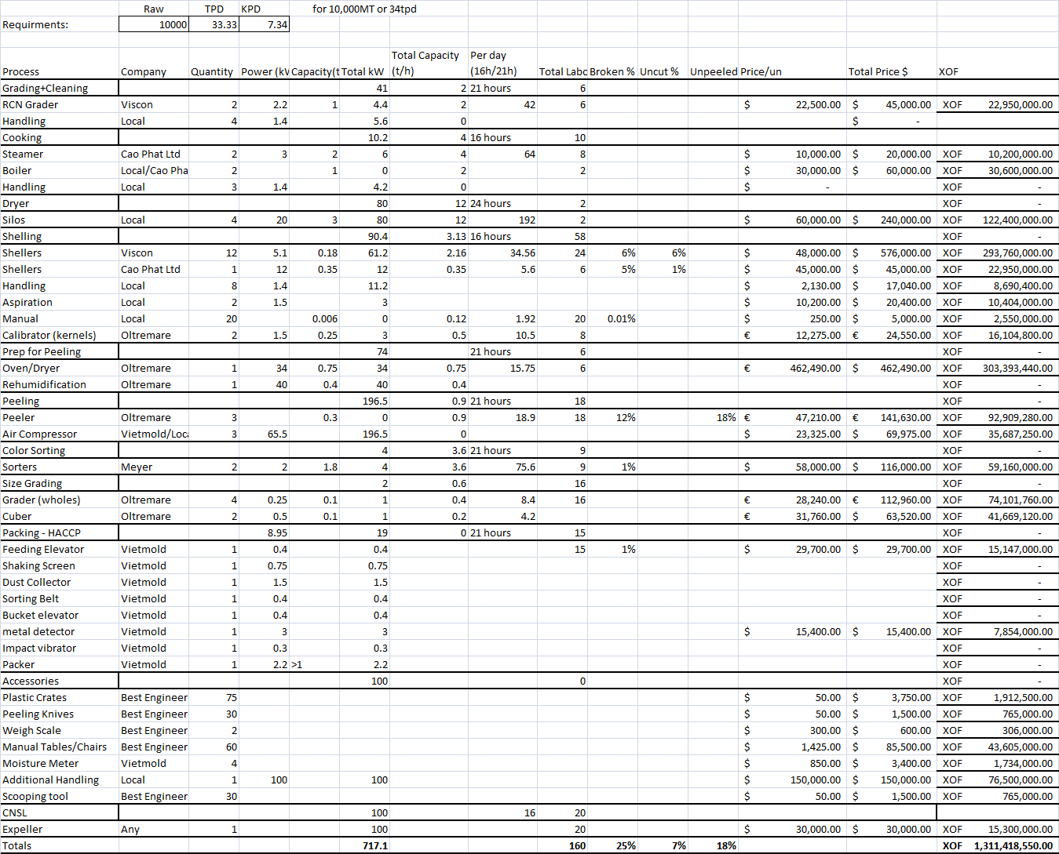

Year 2 Machine Requirements

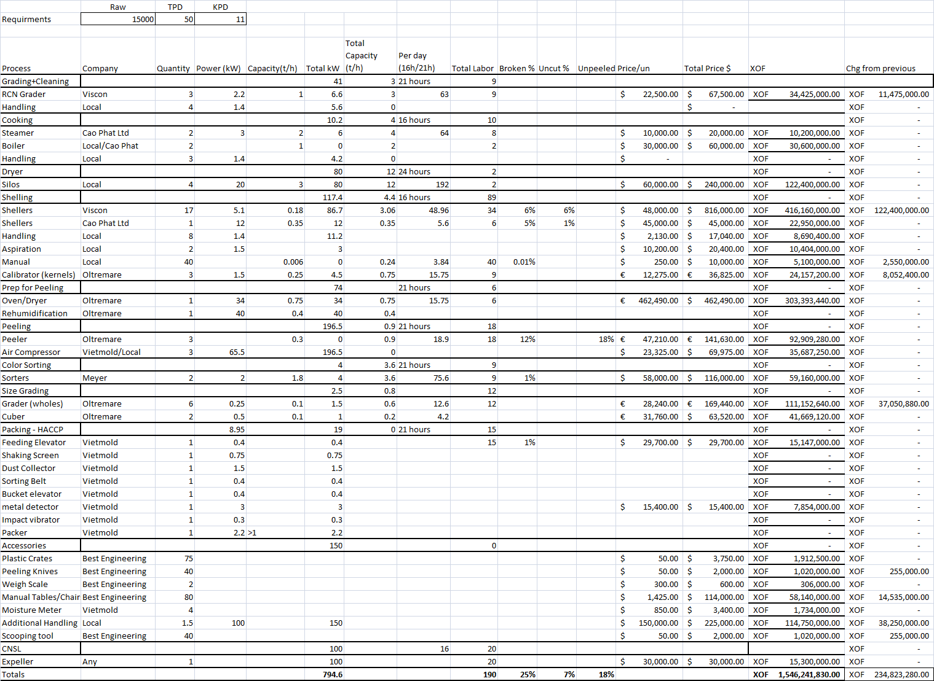

Year 3 Machine Requirements

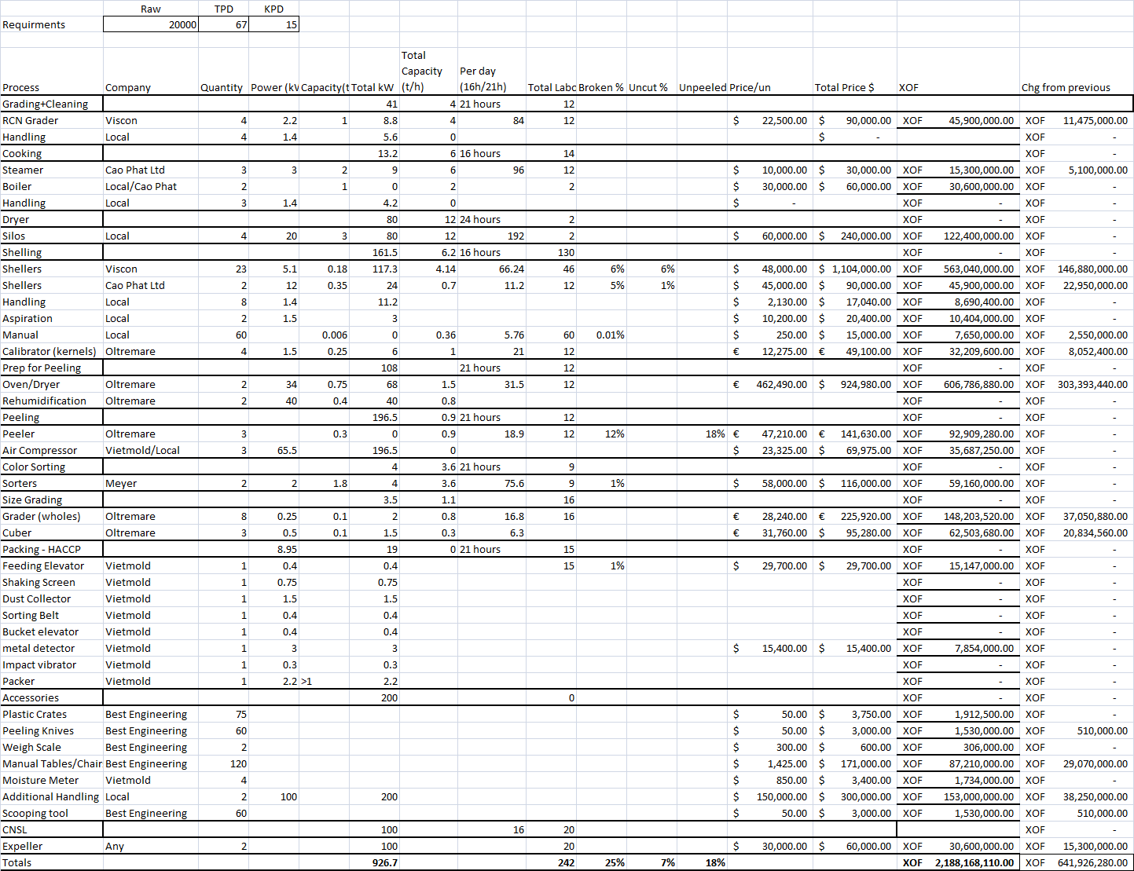

Year 4 Machine Requirements

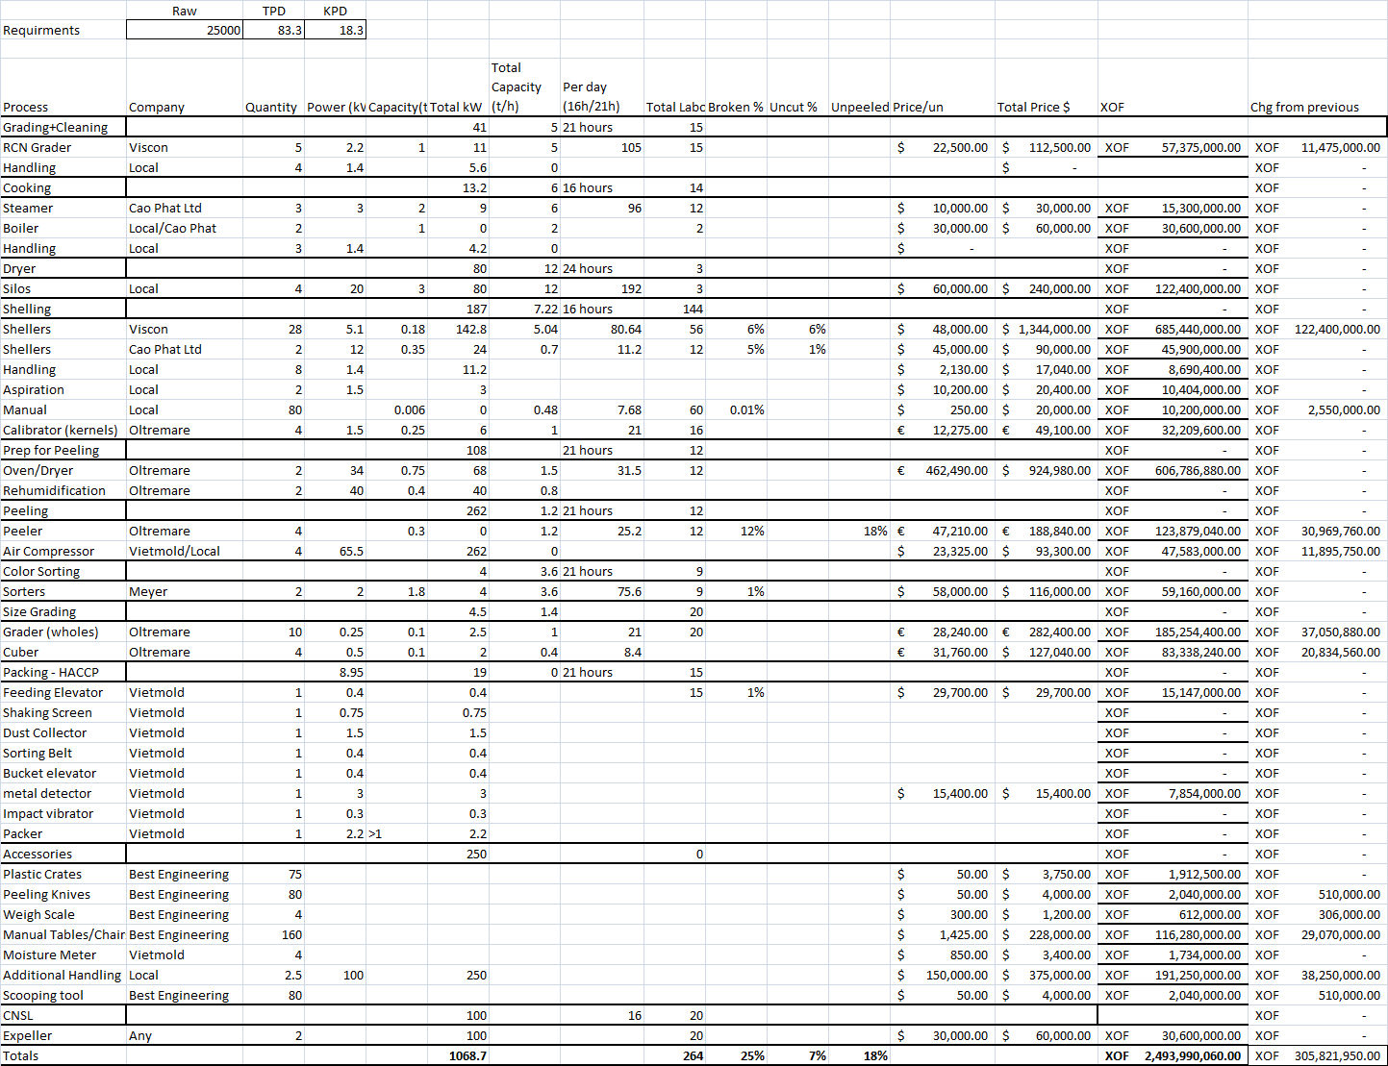

Year 5 Machine Requirements

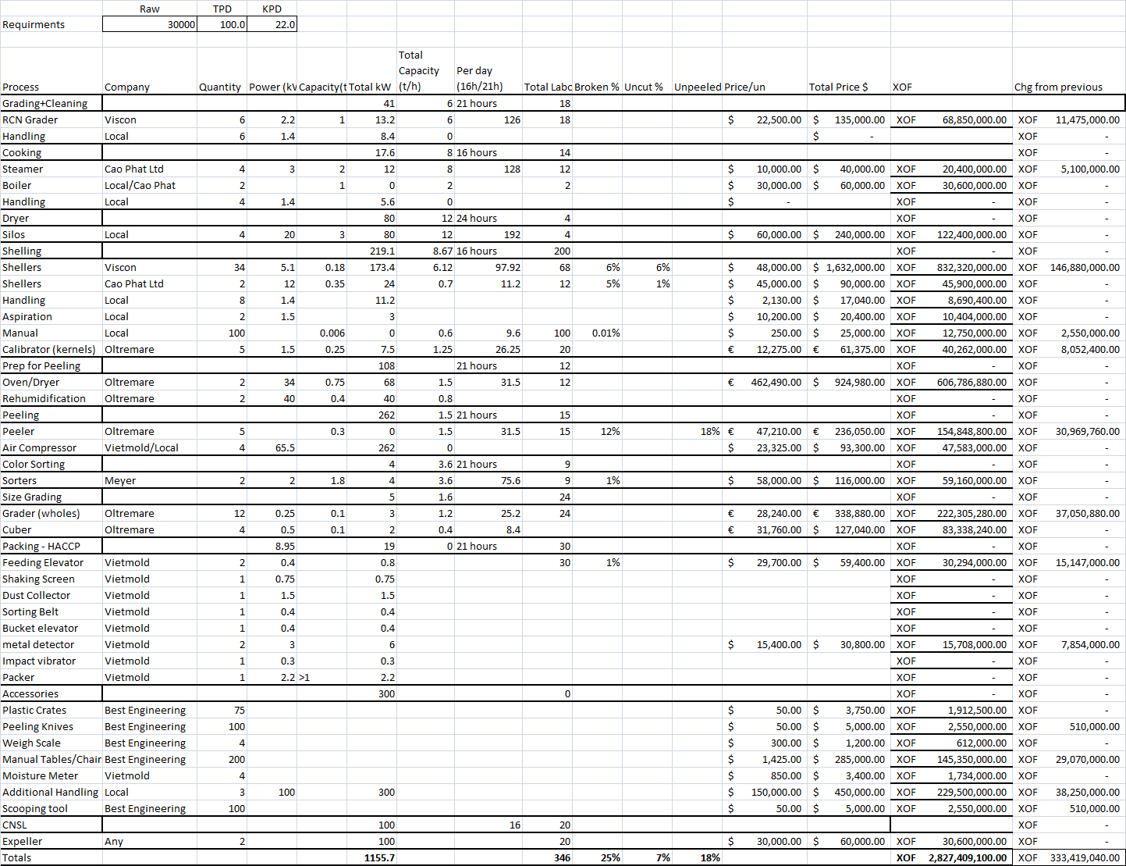

4. Required Working Capital - Year 1

|  |  |  |  |  |  |
| --- | --- | --- | --- | --- | --- |
|  |  |  |  | Per Month | Per Year |
|  |  |  | Total | **XOF 410,597,833.95** | **XOF 4,927,174,007.35** |
| Item List |  |  |  | Amount/Mo | Amount/Year |
| **Labor** | | **Qty** | **wage** | **XOF 58,850,000.00** | **XOF 706,200,000.00** |
| Production Manager | | 1 | XOF 1,500,000.00 | XOF 1,500,000.00 | XOF 18,000,000.00 |
| Managerial | | 24 | XOF 500,000.00 | XOF 12,000,000.00 | XOF 144,000,000.00 |
| Skilled | | 6 | XOF 750,000.00 | XOF 4,500,000.00 | XOF 54,000,000.00 |
| Administrative | | 8 | XOF 750,000.00 | XOF 6,000,000.00 | XOF 72,000,000.00 |
| Unskilled | | 410 | XOF 85,000.00 | XOF 34,850,000.00 | XOF 418,200,000.00 |
| **Raw Material** | | **Qty** | **FCFA** | **XOF 271,050,000.00** | **XOF 3,252,600,000.00** |
| RCN(MT) | | 834 | XOF 325,000.00 | XOF 271,050,000.00 | XOF 3,252,600,000.00 |
| **Utilities** | | **Qty** | **FCFA** | **XOF 45,652,830.00** | **XOF 547,833,960.00** |
| Electricity | | 967.1 | XOF 75.00 | XOF 39,167,550.00 | XOF 470,010,600.00 |
| Petrol | | ? |  |  | XOF - |
| Transportation | | 320 | XOF 20,000.00 | XOF 6,400,000.00 | XOF 76,800,000.00 |
| Water | | 208 | XOF 410.00 | XOF 85,280.00 | XOF 1,023,360.00 |
| **Packaging Material** | | **Qty** | **FCFA** | **XOF 14,000,324.64** | **XOF 168,003,895.68** |
| sac Jutes (80kg) | | 10425 | XOF 900.00 | XOF 9,382,500.00 | XOF 112,590,000.00 |
| Bags of 25lb (58.5x68.5x5)cm | | 8073.12 | XOF 357.00 | XOF 2,882,103.84 | XOF 34,585,246.08 |
| Bags of 50lb (58.5x78.75x5)cm | | 4037 | XOF 430.00 | XOF 1,735,720.80 | XOF 20,828,649.60 |
| CNSL bottles | |  |  | XOF - | XOF - |
| Package Cartons | | 8073.12 |  | XOF - | XOF - |
| Inert Gas.(CO2) | |  |  | XOF - | XOF - |
| **Spares and Maintenance** | |  |  | **XOF 10,972,829.31** | **XOF 131,673,951.67** |
| Technicians | |  | XOF 3,472,829.31 | XOF 3,472,829.31 | XOF 41,673,951.67 |
| Spare Parts | |  | XOF 7,500,000.00 | XOF 7,500,000.00 | XOF 90,000,000.00 |
| **Taxes** | | **Qty** |  | **XOF 5,771,850.00** | **XOF 69,262,200.00** |
| Labor | | 21% | XOF 27,485,000.00 | XOF 5,771,850.00 | XOF 69,262,200.00 |
| Sur exports | | 0% |  |  |  |
| Sales/Profits | | N/A |  |  | XOF - |
| **Other Expenses** | | **Qty** |  | **XOF 4,300,000.00** | **XOF 51,600,000.00** |
| Insurance | | 1 | XOF 3,500,000.00 | XOF 3,500,000.00 | XOF 42,000,000.00 |
| Office Material | | N/A |  | XOF 400,000.00 | XOF 4,800,000.00 |
| Internet and Phone | | N/A |  | XOF 400,000.00 | XOF 4,800,000.00 |

Required Working Capital Year 2

|  |  |  |  |  |  |
| --- | --- | --- | --- | --- | --- |
|  |  |  |  | Per Month | Per Year |
|  |  |  | Total | **XOF 578,642,029.17** | **XOF 6,943,704,350.00** |
| Item List | |  |  | Amount/Mo | Tot/Year |
| **Labor** | | **Qty** | **wage** | **XOF 73,975,000.00** | **XOF 887,700,000.00** |
| Production Manager | | 1 | XOF 1,500,000.00 | XOF 1,500,000.00 | XOF 18,000,000.00 |
| Managerial | | 24 | XOF 500,000.00 | XOF 12,000,000.00 | XOF 144,000,000.00 |
| Skilled | | 10 | XOF 750,000.00 | XOF 7,500,000.00 | XOF 90,000,000.00 |
| Administrative | | 10 | XOF 750,000.00 | XOF 7,500,000.00 | XOF 90,000,000.00 |
| Unskilled | | 535 | XOF 85,000.00 | XOF 45,475,000.00 | XOF 545,700,000.00 |
| **Raw Material** | | **Qty** | **FCFA** | **XOF 406,250,000.00** | **XOF 4,875,000,000.00** |
| RCN(MT) | | 1250 | XOF 325,000.00 | XOF 406,250,000.00 | XOF 4,875,000,000.00 |
| **Utilities** | | **Qty** | **FCFA** | **XOF 51,641,580.00** | **XOF 619,698,960.00** |
| Electricity | | 1044.6 | XOF 75.00 | XOF 42,306,300.00 | XOF 507,675,600.00 |
| Petrol | | ? |  |  | XOF - |
| Transportation | | 462.5 | XOF 20,000.00 | XOF 9,250,000.00 | XOF 111,000,000.00 |
| Water | | 208 | XOF 410.00 | XOF 85,280.00 | XOF 1,023,360.00 |
| **Packaging Material** | | **Qty** | **FCFA** | **XOF 20,983,700.00** | **XOF 251,804,400.00** |
| sac Jutes (80kg) | | 15625 | XOF 900.00 | XOF 14,062,500.00 | XOF 168,750,000.00 |
| Bags of 25lb (58.5x68.5x5)cm | | 12100 | XOF 357.00 | XOF 4,319,700.00 | XOF 51,836,400.00 |
| Bags of 50lb (58.5x78.75x5)cm | | 6050 | XOF 430.00 | XOF 2,601,500.00 | XOF 31,218,000.00 |
| CNSL bottles | |  |  | XOF - | XOF - |
| Package Cartons | | 12100 |  | XOF - | XOF - |
| Inert Gas.(CO2) | |  |  | XOF - | XOF - |
| **Spares and Maintenance** | |  |  | **XOF 14,301,774.17** | **XOF 171,621,290.00** |
| Technicians | |  | XOF 4,301,774.17 | XOF 4,301,774.17 | XOF 51,621,290.00 |
| Spare Parts | |  | XOF 10,000,000.00 | XOF 10,000,000.00 | XOF 120,000,000.00 |
| **Taxes** | | **Qty** |  | **XOF 6,939,975.00** | **XOF 83,279,700.00** |
| Labor | | 21% | XOF 33,047,500.00 | XOF 6,939,975.00 | XOF 83,279,700.00 |
| Sur exports | |  |  |  |  |
| Sales/Profits | | N/A |  |  | XOF - |
| **Other Expenses** | | **Qty** |  | **XOF 4,550,000.00** | **XOF 54,600,000.00** |
| Insurance | | 1 | XOF 3,750,000.00 | XOF 3,750,000.00 | XOF 45,000,000.00 |
| Office Material | | N/A |  | XOF 400,000.00 | XOF 4,800,000.00 |
| Internet and Phone | | N/A |  | XOF 400,000.00 | XOF 4,800,000.00 |

Total Change from Year 1: XOF 2,016,530,342.65

Required Working Capital Year 3

|  |  |  |  |  |  |
| --- | --- | --- | --- | --- | --- |
|  |  |  |  | Per Month | Per Year |
|  |  |  | Total | **XOF 809,355,686.49** | **XOF 9,712,268,237.84** |
| Item List |  |  |  | Amount/Mo | Tot/Year |
| **Labor** | | **Qty** | **wage** | **XOF 95,020,000.00** | **XOF 1,140,240,000.00** |
| Production Manager | | 1 | XOF 1,500,000.00 | XOF 1,500,000.00 | XOF 18,000,000.00 |
| Managerial | | 24 | XOF 500,000.00 | XOF 12,000,000.00 | XOF 144,000,000.00 |
| Skilled | | 16 | XOF 750,000.00 | XOF 12,000,000.00 | XOF 144,000,000.00 |
| Administrative | | 12 | XOF 750,000.00 | XOF 9,000,000.00 | XOF 108,000,000.00 |
| Unskilled | | 712 | XOF 85,000.00 | XOF 60,520,000.00 | XOF 726,240,000.00 |
| **Raw Material** | | **Qty** | **FCFA** | **XOF 595,952,500.00** | **XOF 7,151,430,000.00** |
| RCN(MT) | | 1667 | XOF 357,500.00 | XOF 595,952,500.00 | XOF 7,151,430,000.00 |
| **Utilities** | | **Qty** | **FCFA** | **XOF 60,081,630.00** | **XOF 720,979,560.00** |
| Electricity | | 1176.7 | XOF 75.00 | XOF 47,656,350.00 | XOF 571,876,200.00 |
| Petrol | | ? |  |  | XOF - |
| Transportation | | 617 | XOF 20,000.00 | XOF 12,340,000.00 | XOF 148,080,000.00 |
| Water | | 208 | XOF 410.00 | XOF 85,280.00 | XOF 1,023,360.00 |
| **Packaging Material** | | **Qty** | **FCFA** | **XOF 27,983,862.32** | **XOF 335,806,347.84** |
| sac Jutes (80kg) | | 20837.5 | XOF 900.00 | XOF 18,753,750.00 | XOF 225,045,000.00 |
| Bags of 25lb (58.5x68.5x5)cm | | 16136.56 | XOF 357.00 | XOF 5,760,751.92 | XOF 69,129,023.04 |
| Bags of 50lb (58.5x78.75x5)cm | | 8068 | XOF 430.00 | XOF 3,469,360.40 | XOF 41,632,324.80 |
| CNSL bottles | |  |  | XOF - | XOF - |
| Package Cartons | | 16136.56 |  | XOF - | XOF - |
| Inert Gas.(CO2) | |  |  | XOF - | XOF - |
| **Spares and Maintenance** | |  |  | **XOF 16,801,774.17** | **XOF 201,621,290.00** |
| Technicians | |  | XOF 4,301,774.17 | XOF 4,301,774.17 | XOF 51,621,290.00 |
| Spare Parts | |  | XOF 12,500,000.00 | XOF 12,500,000.00 | XOF 150,000,000.00 |
| **Taxes** | | **Qty** |  | **XOF 8,515,920.00** | **XOF 102,191,040.00** |
| Labor | | 21% | XOF 40,552,000.00 | XOF 8,515,920.00 | XOF 102,191,040.00 |
| Sur exports | |  |  |  |  |
| Sales/Profits | | N/A |  |  | XOF - |
| **Other Expenses** | | **Qty** |  | **XOF 5,000,000.00** | **XOF 60,000,000.00** |
| Insurance | | 1 | XOF 4,000,000.00 | XOF 4,000,000.00 | XOF 48,000,000.00 |
| Office Material | | N/A |  | XOF 500,000.00 | XOF 6,000,000.00 |
| Internet and Phone | | N/A |  | XOF 500,000.00 | XOF 6,000,000.00 |

Total change from Year 2: XOF 2,768,563,887.84

Required Working Capital Year 4

|  |  |  |  |  |  |
| --- | --- | --- | --- | --- | --- |
|  |  |  |  | Per Month | Per Year |
|  |  |  | Total | **XOF 991,050,981.72** | **XOF 11,892,611,780.68** |
| Item List |  |  |  | Amount/Mo | Tot/Year |
| **Labor** | | **qty** | **wage** | **XOF 110,415,000.00** | **XOF 1,324,980,000.00** |
| Production Manager | | 1 | XOF 1,500,000.00 | XOF 1,500,000.00 | XOF 18,000,000.00 |
| Managerial | | 24 | XOF 500,000.00 | XOF 12,000,000.00 | XOF 144,000,000.00 |
| Skilled | | 18 | XOF 750,000.00 | XOF 13,500,000.00 | XOF 162,000,000.00 |
| Administrative | | 15 | XOF 750,000.00 | XOF 11,250,000.00 | XOF 135,000,000.00 |
| Unskilled | | 849 | XOF 85,000.00 | XOF 72,165,000.00 | XOF 865,980,000.00 |
| **Raw Material** | | **qty** | **FCFA** | **XOF 744,790,475.00** | **XOF 8,937,485,700.00** |
| RCN(MT) | | 2083.33 | XOF 357,500.00 | XOF 744,790,475.00 | XOF 8,937,485,700.00 |
| **Utilities** | | **qty** | **FCFA** | **XOF 68,912,630.00** | **XOF 826,951,560.00** |
| Electricity | | 1318.7 | XOF 75.00 | XOF 53,407,350.00 | XOF 640,888,200.00 |
| Petrol | | ? |  |  | XOF - |
| Transportation | | 771 | XOF 20,000.00 | XOF 15,420,000.00 | XOF 185,040,000.00 |
| Water | | 208 | XOF 410.00 | XOF 85,280.00 | XOF 1,023,360.00 |
| **Packaging Material** | | **qty** | **FCFA** | **XOF 34,984,024.64** | **XOF 419,808,295.68** |
| sac Jutes (80kg) | | 26050 | XOF 900.00 | XOF 23,445,000.00 | XOF 281,340,000.00 |
| Bags of 25lb (58.5x68.5x5)cm | | 20173.12 | XOF 357.00 | XOF 7,201,803.84 | XOF 86,421,646.08 |
| Bags of 50lb (58.5x78.75x5)cm | | 10087 | XOF 430.00 | XOF 4,337,220.80 | XOF 52,046,649.60 |
| CNSL bottles | |  |  | XOF - | XOF - |
| Package Cartons | | 20173.12 |  | XOF - | XOF - |
| Inert Gas.(CO2) | |  |  | XOF - | XOF - |
| **Spares and Maintenance** | |  |  | **XOF 17,150,887.08** | **XOF 205,810,645.00** |
| Technicians | |  | XOF 2,150,887.08 | XOF 2,150,887.08 | XOF 25,810,645.00 |
| Spare Parts | |  | XOF 15,000,000.00 | XOF 15,000,000.00 | XOF 180,000,000.00 |
| **Taxes** | | **qty** |  | **XOF 9,547,965.00** | **XOF 114,575,580.00** |
| Labor | | 21% | XOF 45,466,500.00 | XOF 9,547,965.00 | XOF 114,575,580.00 |
| Sur exports | |  |  |  |  |
| Sales/Profits | | N/A |  |  | XOF - |
| **Other Expenses** | | qte |  | **XOF 5,250,000.00** | **XOF 63,000,000.00** |
| Insurance | | 1 | XOF 4,250,000.00 | XOF 4,250,000.00 | XOF 51,000,000.00 |
| Office Material | | N/A |  | XOF 500,000.00 | XOF 6,000,000.00 |
| Internet and Phone | | N/A |  | XOF 500,000.00 | XOF 6,000,000.00 |

Total change from Year 3: XOF 2,180,343,542.84

Required Working Capital Year 5

|  |  |  |  |  |  |
| --- | --- | --- | --- | --- | --- |
|  |  |  |  | Per Month | Per Year |
|  |  |  | Total | **XOF 1,175,104,402.08** | **XOF 14,101,252,825.00** |
| Item List |  |  |  | Amount/Mo | Tot/Year |
| **Labor** | | **Qty** | **wage** | **XOF 128,035,000.00** | **XOF 1,536,420,000.00** |
| Production Manager | | 1 | XOF 1,500,000.00 | XOF 1,500,000.00 | XOF 18,000,000.00 |
| Managerial | | 24 | XOF 500,000.00 | XOF 12,000,000.00 | XOF 144,000,000.00 |
| Skilled | | 20 | XOF 750,000.00 | XOF 15,000,000.00 | XOF 180,000,000.00 |
| Administrative | | 17 | XOF 750,000.00 | XOF 12,750,000.00 | XOF 153,000,000.00 |
| Unskilled | | 1021 | XOF 85,000.00 | XOF 86,785,000.00 | XOF 1,041,420,000.00 |
| **Raw Material** | | **Qty** | **FCFA** | **XOF 893,750,000.00** | **XOF 10,725,000,000.00** |
| RCN(MT) | | 2500 | XOF 357,500.00 | XOF 893,750,000.00 | XOF 10,725,000,000.00 |
| **Utilities** | | **Qty** | **FCFA** | **XOF 75,516,130.00** | **XOF 906,193,560.00** |
| Electricity | | 1405.7 | XOF 75.00 | XOF 56,930,850.00 | XOF 683,170,200.00 |
| Petrol | | ? |  |  | XOF - |
| Transportation | | 925 | XOF 20,000.00 | XOF 18,500,000.00 | XOF 222,000,000.00 |
| Water | | 208 | XOF 410.00 | XOF 85,280.00 | XOF 1,023,360.00 |
| **Packaging Material** | | **Qty** | **FCFA** | **XOF 41,967,400.00** | **XOF 503,608,800.00** |
| sac Jutes (80kg) | | 31250 | XOF 900.00 | XOF 28,125,000.00 | XOF 337,500,000.00 |
| Bags of 25lb (58.5x68.5x5)cm | | 24200 | XOF 357.00 | XOF 8,639,400.00 | XOF 103,672,800.00 |
| Bags of 50lb (58.5x78.75x5)cm | | 12100 | XOF 430.00 | XOF 5,203,000.00 | XOF 62,436,000.00 |
| CNSL bottles | |  |  | XOF - | XOF - |
| Package Cartons | | 24200 |  | XOF - | XOF - |
| Inert Gas.(CO2) | |  |  | XOF - | XOF - |
| **Spares and Maintenance** | |  |  | **XOF 19,650,887.08** | **XOF 235,810,645.00** |
| Technicians | |  | XOF 2,150,887.08 | XOF 2,150,887.08 | XOF 25,810,645.00 |
| Spare Parts | |  | XOF 17,500,000.00 | XOF 17,500,000.00 | XOF 210,000,000.00 |
| **Taxes** | | **Qty** |  | **XOF 10,484,985.00** | **XOF 125,819,820.00** |
| Labor | | 21% | XOF 49,928,500.00 | XOF 10,484,985.00 | XOF 125,819,820.00 |
| Sur exports | |  |  |  |  |
| Sales/Profits | | N/A |  |  | XOF - |
| **Other Expenses** | | **Qty** |  | **XOF 5,700,000.00** | **XOF 68,400,000.00** |
| Insurance | | 1 | XOF 4,500,000.00 | XOF 4,500,000.00 | XOF 54,000,000.00 |
| Office Material | | N/A |  | XOF 600,000.00 | XOF 7,200,000.00 |
| Internet and Phone | | N/A |  | XOF 600,000.00 | XOF 7,200,000.00 |

Total change from Year 4: XOF 2,208,641,044.32

5. Monthly Fluctuations in Outflows for Year 1 (continuous pattern)

6. Revenue Estimation

|  |  |  |  |  |  |  |  |  |  |  |  |  |  |  |  |  |  |  |  |  |
| --- | --- | --- | --- | --- | --- | --- | --- | --- | --- | --- | --- | --- | --- | --- | --- | --- | --- | --- | --- | --- |
|  |  | |  |  |  | |  | |  |  |  |  |  |  |  |  |  | |  |  |
| *Prices are based on prices of Rotterdam, Vietnam, and two Indian Ports during 09/10 of 2014 (lower end of the spectrum) | | | | | | | MT Processed | | | 10000 | Broken | 35.00% | Prix/kg | FCFA325 |  |  |  | |  |  |
| Kernels (MT) | | | 2200 | Scorched | 23.36% | Machines | Mixed |  |  |  | |  | |
| Loss Estimate | | | 5% |  |  |  |  |  |  |  | |  |  |
| Simplest Export View with $.50 discount | | | | | | |  | |  |  |  |  |  |  |  |  |  | |  |  |
|  | Percent of 1 ton | | | KG | KGs/T of K | | | | in lbs | Price in 9/10-14 FoB $/lb* | | Value as % of ton | | Total output (MT) | Total Production(MT) | | In lbs | | Total Value Produced | |
| WW | 50.00% | | | 1000 | 500 | | | | 1100 | $3.10 | | $3,410.00 | | 2090 | 1045.00 | | 2299000 | | $7,126,900.00 | |
| SW | 15.00% | | | 1000 | 150 | | | | 330 | $2.55 | | $841.50 | | 2090 | 313.50 | | 689700 | | $1,758,735.00 | |
| WP | 26.64% | | | 1000 | 266.4 | | | | 586.08 | $2.12 | | $1,242.49 | | 2090 | 556.78 | | 1224907 | | $2,596,803.26 | |
| SP | 8.3600% | | | 1000 | 83.6 | | | | 183.92 | $1.32 | | $242.77 | | 2090 | 174.72 | | 384393 | | $507,398.50 | |
| Total | 100.00% | |  |  | 1000 | | | | 2200 | $2.61 | | $5,736.76 | |  | 2090.00 | | 4598000 | | $11,989,836.76 | |
| Broken |  | | 35.00% |  |  | |  | |  |  |  |  |  |  |  |  |  | |  |  |
| Scorched |  | | 23.36% |  |  | |  | |  |  |  |  |  |  |  |  |  | |  |  |
|  |  | |  |  |  | |  | |  |  |  |  |  |  |  |  |  | |  |  |
| Simplest View of Export | | | | | | |  | |  |  |  |  |  |  |  |  |  | |  |  |
|  | Percent of 1 ton | | | KG | | KGs/T of K | | | in lbs | Price in 9/10-14 FoB $/lb* | | Value as % of ton | | Total output (MT) | Total Production(MT) | | In lbs | | Total Value Produced | |
| WW | 50.00% | | | 1000 | | 500 | | | 1100 | $3.60 | | $3,960.00 | | 2090 | 1045.00 | | 2299000 | | $8,276,400.00 | |
| SW | 15.00% | | | 1000 | | 150 | | | 330 | $3.05 | | $1,006.50 | | 2090 | 313.50 | | 689700 | | $2,103,585.00 | |
| WP | 26.64% | | | 1000 | | 266.4 | | | 586.08 | $2.62 | | $1,535.53 | | 2090 | 556.78 | | 1224907 | | $3,209,256.86 | |
| SP | 8.3600% | | | 1000 | | 83.6 | | | 183.92 | $1.82 | | $334.73 | | 2090 | 174.72 | | 384393 | | $699,594.90 | |
| Total | 100.00% | |  |  | | 1000 | | | 2200 | $3.11 | | $6,836.76 | |  | 2090.00 | | 4598000 | | $14,288,836.76 | |
|  |  | |  |  | |  | |  |  |  |  |  |  |  |  |  |  | |  |  |
|  |  | |  |  | |  | |  |  |  |  |  |  |  |  |  |  | |  |  |
|  |  | |  |  | |  | |  |  |  |  |  |  |  |  |  |  | |  |  |
| Very | Simple | | View | $.50 | | Discount | |  |  |  |  |  |  |  |  |  |  | |  |  |
|  | Percent of 1 ton | | | KG | | KGs/T of K | | | in lbs | Price in 9/10-14 FoB $/lb* | | Value as % of ton | | Total output (MT) | Total Production(MT) | | In lbs | | Total Value Produced | |
| WW210 | 15.50% | | | 1000 | | 155 | | | 341 | $3.50 | | $1,193.50 | | 2090 | 323.950 | | 712690 | | $2,494,415.00 | |
| WW240 | 12.00% | | | 1000 | | 120 | | | 264 | $3.30 | | $871.20 | | 2090 | 250.800 | | 551760 | | $1,820,808.00 | |
| WW320 | 12.00% | | | 1000 | | 120 | | | 264 | $3.15 | | $831.60 | | 2090 | 250.800 | | 551760 | | $1,738,044.00 | |
| WW450 | 10.50% | | | 1000 | | 105 | | | 231 | $2.72 | | $628.32 | | 2090 | 219.450 | | 482790 | | $1,313,188.80 | |
| SW | 15.00% | | | 1000 | | 150 | | | 330 | $2.47 | | $815.10 | | 2090 | 313.500 | | 689700 | | $1,703,559.00 | |
| LWP | 15.94% | | | 1000 | | 159.4 | | | 350.68 | $2.21 | | $775.00 | | 2090 | 333.146 | | 732921 | | $1,619,755.85 | |
| SWP | 10.70% | | | 1000 | | 107 | | | 235.4 | $2.03 | | $477.86 | | 2090 | 223.630 | | 491986 | | $998,731.58 | |
| SP | 8.3600% | | | 1000 | | 83.6 | | | 183.92 | $1.32 | | $242.77 | | 2090 | 174.724 | | 384393 | | $507,398.50 | |
| Total | 100.00% | | |  | | 1000 | | | 2200 | $2.65 | | $5,835.36 | |  | 2090.000 | | 4598000 | | $12,195,900.73 | |
| Broken | | | 35.00% |  | |  |  | |  |  |  |  |  |  |  |  |  | |  |  |
| Scorched | | | 23.36% |  | |  |  | |  |  |  |  |  |  |  |  |  | |  |  |
| Very Simple Export View | | | | | | | | | |  |  |  |  |  |  |  |  | |  |  |
|  | Percent of 1 ton | | | KG | KGs/T of K | | | | in lbs | Price in 9/10-14 FoB $/lb* | | Value as % of ton | | Total output (MT) | Total Production(MT) | | In lbs | | Total Value Produced | |
| WW210 | 15.50% | | | 1000 | 155 | | | | 341 | $4.00 | | $1,364.00 | | 2090 | 323.950 | | 712690 | | $2,850,760.00 | |
| WW240 | 12.00% | | | 1000 | 120 | | | | 264 | $3.80 | | $1,003.20 | | 2090 | 250.800 | | 551760 | | $2,096,688.00 | |
| WW320 | 12.00% | | | 1000 | 120 | | | | 264 | $3.65 | | $963.60 | | 2090 | 250.800 | | 551760 | | $2,013,924.00 | |
| WW450 | 10.50% | | | 1000 | 105 | | | | 231 | $3.22 | | $743.82 | | 2090 | 219.450 | | 482790 | | $1,554,583.80 | |
| SW | 15.00% | | | 1000 | 150 | | | | 330 | $3.05 | | $1,006.50 | | 2090 | 313.500 | | 689700 | | $2,103,585.00 | |
| LWP | 15.94% | | | 1000 | 159.4 | | | | 350.68 | $2.71 | | $950.34 | | 2090 | 333.146 | | 732921 | | $1,986,216.45 | |
| SWP | 10.7000% | | | 1000 | 107 | | | | 235.4 | $2.53 | | $595.56 | | 2090 | 223.630 | | 491986 | | $1,244,724.58 | |
| SP | 8.3600% | | | 1000 | 83.6 | | | | 183.92 | $1.82 | | $334.73 | | 2090 | 174.724 | | 384393 | | $699,594.90 | |
| Total | 100.000% | | |  | 1000 | | | | 2200 | $3.16 | | $6,961.76 | |  | 2090.000 | | 4598000 | | $14,550,076.73 | |
| Broken | | | 35.00% |  |  | |  | |  |  |  |  |  |  |  |  |  | |  |  |
| Scorched | | | 23.36% |  |  | |  | |  |  |  |  |  |  |  |  |  | |  |  |
|  | Simple Export View | | | | | |  | |  |  |  |  |  |  |  |  |  | |  |  |
|  | Percent of 1 ton | | | KG | KGs/T of K | | | | in lbs | Price in 9/10-14 FoB $/lb* | | Value as % of ton | | Total output (MT) | Total Production(MT) | | In lbs | | Total Value Produced | |
| WW210 | 15.50% | | | 1000 | 155 | | | | 341 | $4.00 | | $1,364.00 | | 2090 | 323.950 | | 712690 | | $2,850,760.00 | |
| WW240 | 12.00% | | | 1000 | 120 | | | | 264 | $3.80 | | $1,003.20 | | 2090 | 250.800 | | 551760 | | $2,096,688.00 | |
| WW320 | 12.00% | | | 1000 | 120 | | | | 264 | $3.65 | | $963.60 | | 2090 | 250.800 | | 551760 | | $2,013,924.00 | |
| WW450 | 10.50% | | | 1000 | 105 | | | | 231 | $3.22 | | $743.82 | | 2090 | 219.450 | | 482790 | | $1,554,583.80 | |
| S240 | 5.50% | | | 1000 | 55 | | | | 121 | $3.20 | | $387.20 | | 2090 | 114.950 | | 252890 | | $809,248.00 | |
| S320 | 4.50% | | | 1000 | 45 | | | | 99 | $3.10 | | $306.90 | | 2090 | 94.050 | | 206910 | | $641,421.00 | |
| SSW | 5.00% | | | 1000 | 50 | | | | 110 | $2.70 | | $297.00 | | 2090 | 104.500 | | 229900 | | $620,730.00 | |
| LWP | 15.94% | | | 1000 | 159.4 | | | | 350.68 | $2.71 | | $950.34 | | 2090 | 333.146 | | 732921 | | $1,986,216.45 | |
| SWP | 5.20% | | | 1000 | 51.975 | | | | 114.345 | $2.53 | | $289.29 | | 2090 | 108.628 | | 238981 | | $604,622.06 | |
| BB | 5.50% | | | 1000 | 55 | | | | 121 | $1.80 | | $217.80 | | 2090 | 114.950 | | 252890 | | $455,202.00 | |
| SP | 8.36% | | | 1000 | 83.625 | | | | 183.975 | $1.82 | | $334.83 | | 2090 | 174.776 | | 384508 | | $699,804.11 | |
| Total | | 100.00% | |  | 1000 | | | | 2200 | $3.12 | | $6,857.99 | |  | 2090.000 | | 4,598,000 | | $14,333,199.41 | |
| Scorched | | 23.36% | |  |  | |  | |  |  |  |  |  |  |  |  |  | |  |  |
| Broken | | 35.00% | |  |  | |  | |  |  |  |  |  |  |  |  |  | |  |  |
| Detailed View- WW | | |  |  | |  |  | |  |  |  |  |  |  |  |  |  | |  |  |
|  | Percent of 1 ton | | | KG | | KGs/T of K | | | in lbs | Price in 9/10-14 FoB $/lb* | | Value as % of ton | | Total output (MT) | Total Production(MT) | | In lbs | | Total Value Produced | |
| WW180 | 5.50% | | | 1000 | | 55 | | | 121 | $4.50 | | $544.50 | | 2090 | 114.95 | | 252890 | | $1,138,005.00 | |
| WW210 | 10.00% | | | 1000 | | 100 | | | 220 | $4.00 | | $880.00 | | 2090 | 209.00 | | 459800 | | $1,839,200.00 | |
| WW240 | 12.00% | | | 1000 | | 120 | | | 264 | $3.80 | | $1,004.26 | | 2090 | 250.80 | | 551760 | | $2,098,895.04 | |
| WW320 | 12.00% | | | 1000 | | 120 | | | 264 | $3.34 | | $881.01 | | 2090 | 250.80 | | 551760 | | $1,841,301.94 | |
| WW450 | 7.50% | | | 1000 | | 75 | | | 165 | $3.19 | | $526.56 | | 2090 | 156.75 | | 344850 | | $1,100,502.56 | |
| WW500 | 3.00% | | | 1000 | | 30 | | | 66 | $2.75 | | $181.50 | | 2090 | 62.70 | | 137940 | | $379,335.00 | |
| Total WW | 50.00% | | |  | | 500 | | | 1100 | $3.65 | | $4,017.82 | |  | 1045.000 | | 2299000 | | $8,397,239.55 | |
| Scorched Whole | | |  |  | |  |  | |  |  |  |  |  |  |  |  |  | |  |  |
| SW180 | 0.50% | | | 1000 | | 5 | | | 11 | $3.25 | | $35.75 | | 2090 | 10.45 | | 22990 | | $74,717.50 | |
| SW210 | 2.00% | | | 1000 | | 20 | | | 44 | $3.20 | | $140.80 | | 2090 | 41.80 | | 91960 | | $294,272.00 | |
| SW240 | 3.00% | | | 1000 | | 30 | | | 66 | $3.20 | | $211.20 | | 2090 | 62.70 | | 137940 | | $441,408.00 | |
| SW320 | 2.50% | | | 1000 | | 25 | | | 55 | $3.10 | | $170.50 | | 2090 | 52.25 | | 114950 | | $356,345.00 | |
| SW450 | 1.25% | | | 1000 | | 12.5 | | | 27.5 | $2.85 | | $78.38 | | 2090 | 26.13 | | 57475 | | $163,803.75 | |
| SW500 | 0.75% | | | 1000 | | 7.5 | | | 16.5 | $2.20 | | $36.30 | | 2090 | 15.68 | | 34485 | | $75,867.00 | |
| Total Whole Scorched | | | 10.00% |  | | 100 | | | 220 | $3.06 | | $672.93 | |  | 209.00 | | 459,800 | | $1,406,413.25 | |
| DW | 2.50% | | | 1000 | | 25 | | | 55 | $2.70 | | $148.50 | | 2090 | 52.25 | | 114950 | | $310,365.00 | |
| SSW | 2.50% | | | 1000 | | 25 | | | 55 | $2.70 | | $148.50 | | 2090 | 52.25 | | 114950 | | $310,365.00 | |
| Scorched | | | 5.00% |  | | 50 | | | 110 | $2.70 | | $297.00 | |  | 104.50 | | 229,900 | | $620,730.00 | |
| Butts | 5.50% | | | 1000 | | 55 | | | 121 | $2.87 | | $347.27 | | 2090 | 114.95 | | | 252890 | $725,794.30 | |
| Splits | 9.10% | | | 1000 | | 91 | | | 200.2 | $3.06 | | $612.61 | | 2090 | 190.19 | | | 418418 | $1,280,359.08 | |
| LWP | 3.34% | | | 1000 | | 33.4 | | | 73.48 | $2.71 | | $199.13 | | 2090 | 69.806 | | | 153573 | $416,183.37 | |
| SWP | 3.1975% | | | 1000 | | 31.975 | | | 70.345 | $2.53 | | $177.97 | | 2090 | 66.82775 | | | 147021 | $371,963.26 | |
| Baby Bits | 5.50% | | | 1000 | | 55 | | | 121 | $1.81 | | $219.01 | | 2090 | 114.95 | | | 252890 | $457,730.90 | |
| White Pieces |  | | 26.6375% |  | | 266.375 | | | 586.025 | $2.66 | | $1,556.00 | |  | 556.72 | | | 1224792 | $3,252,030.91 | |
| SB | 1.70% | | | 1000 | | 17 | | | 37.4 | $2.00 | | $74.80 | | 2090 | 35.53 | | | 78166 | $156,332.00 | |
| SS | 2.75% | | | 1000 | | 27.5 | | | 60.5 | $2.00 | | $121.00 | | 2090 | 57.475 | | | 126445 | $252,890.00 | |
| SP | 1.31% | | | 1000 | | 13.11875 | | | 28.86125 | $1.80 | | $51.95 | | 2090 | 27.4181875 | | | 60320 | $108,576.02 | |
| SSP | 2.60% | | | 1000 | | 26.00625 | | | 57.21375 | $1.50 | | $85.82 | | 2090 | 54.3530625 | | | 119577 | $179,365.11 | |
| Scorched | 8.3625% | | |  | | 83.625 | | | 183.975 | $1.81 | | $333.57 | |  | 174.78 | | | 384508 | $697,163.13 | |
| Total Production | | | 100.00% |  | |  |  | |  |  |  |  |  |  |  |  | |  |  |  |
| Broken | | | 35.00% |  | |  |  | |  |  |  |  |  |  |  |  | |  |  |  |
| Scorched | | | 23.36% |  | |  |  | |  |  |  |  |  |  |  |  | |  |  |  |
|  | Percent Kernel | | |  | | Total kgs produced/t | | | in lbs | Avg price/lb | | Value %/t | | Total t | total produced | | | in lbs | Total Revenue | |
| Totals | 100.00% | | | 1000 | | 1000.00 | | | 2200 | $3.12605 | | $6,877.31 | | 2090 | 2090 | | | 4598000 | $14,373,576.83 | |

7. Loan Preview



8. Year over Year Financial Analysis.



Year over Year (cont)



~~9. Summary of Financial Analysis~~

9. Récapitulatif de l'analyse financière

~~At first glance, processing cashew is extremely profitable. However there are many variables that could have a large impact on the profitability of the operation. The largest variable in processing is the personnel that are controlling the process and training the labor. A production manager that knows the process from A-Z is a must for a facility of this scale. There must also be suitable technicians available at all times. The next important piece is the machines themselves. Regular maintenance and proper repairs is also a must, otherwise all of these estimations do not apply. One item that is not considered in these projections is an increase in technological capability in the industry. According to Oltremare, by the end of 2015 they plan to have a machine that will sort and grade at the same time. Furthermore this machine will sort spotted, stained, moldy, other insect damage and unpeeled before sorting by size. A machine of this nature could remove up to 50% of the required labor, reducing expenses by at least XOF 300 ml in the second year and close to XOF 600 ml in the 5th year.~~ Another item not included in this analysis is how prices of inputs and outputs can affect the profitability. For example, assuming in year one, 10,000MT is processed, the average selling price of the output would need to be at least $2.13/lb to cover the expenses. On the other hand, assuming all expenses are maintained, a minimum of 6,830 MT would need to be processed and sold at the average price of $3.13/lb to break even. Again, because there are many variables that will determine how profitable the facility will be, it is most important to master the process with the correct personnel prior to entering a "full production" phase.

À première vue, la transformation de noix de cajou est extrêmement rentable. Cependant, il ya de nombreuses variables qui pourraient avoir un impact important sur la rentabilité de l'opération. La plus grande variable dans le traitement est le personnel qui contrôlent le processus et la formation de la main-d'œuvre. Un gestionnaire de production que connaît le processus de A à Z est obligatoire pour un établissement de cette envergure. Il doit aussi y avoir des techniciens qualifiés qui sont disponibles en tout temps. La prochaine partie importante est les machines elles-mêmes. Un entretien régulier et les réparations appropriées est également obligatoire, sinon tous ces estimations ne sont pas applicables. Un élément qui ne sont pas pris en compte dans ces projections est une augmentation de la capacité technologique dans le domaine. Selon Oltremare, d'ici la fin de 2015 ils projettent d'avoir une machine qui peut trier et de classer dans le même temps. En outre, cette machine peut trier les grains défectueux avant le tri par taille. Une machine de cette nature pourrait éliminer jusqu'à 50% de la main-d'oeuvre nécessaire, la réduction des dépenses de 300 millions de francs CFA au moins dans la deuxième année et de près de 600 millions de francs CFA à la 5e année. Un autre point non inclus dans cette analyse est de savoir comment les prix des les intrants et les extrants peuvent affecter la rentabilité. Par exemple, en supposant que la première année, 10.000 tonnes est traitée, le prix de vente moyen de la production devrait être au moins 2,13 $ / lb pour couvrir les dépenses. D'autre part, en supposant que toutes les dépenses sont maintenues, un minimum de 6.830MT aurait besoin d'être transformés et vendus au prix moyen de 3,13 $ / lb à l'équilibre. Encore une fois, parce qu'il ya de nombreuses variables qui déterminent la rentabilité de l'installation est, il est très important de maîtriser le processus avec le personnel correctes avant d'entrer dans une phase de "pleine production."

~~Below is a graph of the profit year over year.~~

Ci-dessous un graphique de l'année de bénéfices sur l'année.

~~Profit margins increase with volume. As shown, the profit margins actually peak in the 5th of production. This is because it is the first year that the factory will be processing at the assumed full capacity of 30,000 MT per year and the economies of scale and increase in the productivity of the labor. The profit decreases slightly in the 6th year because of an assumed price increase in raw material. In order to operate in-line with these projections, a large amount of preparation will need to take place.~~

Les marges bénéficiaires augmentent avec le volume. Comme l'a démontré, les marges de profit culminent effectivement dans le 5ème de la production. Ceci est parce que ce sera la première année que l'usine traitera à la pleine capacité supposée de 30 000 tonnes par an et aussi à cause des économies d'échelle et de l'augmentation de la productivité de la main-d'œuvre. Le bénéfice diminue légèrement dans la 6ème année en raison d'une augmentation des prix des matières premières assumé. Afin de suivre ces projections, la préparation est nécessaire.

~~Below is a graph of the Return on Investment on a per year basis.~~

Ci-dessous un graphique de le retour sur investissement sur une base par an.

~~Theoretically, the first year should return 37% of the initial investment. The ROI peaks in the 5th year at 110% of investment (including reinvested capital used to expand capacity). Assuming all necessary steps to succeed are taken, the project should fully recuperate the investment costs by the end of the 3rd year. The IRR over the 15 year period stands at around 68% and the project has a NPV of XOF 246,180,372.79. Both are positive indications of a profitable activity. In addition, at the end of the 15 year period it is estimated that XOF 84,418,948,939.42 ($160,000,000.00) can be accumulated in profit.~~

Théoriquement, la première année devrait retourner 37% de l'investissement initial. Les sommets de ROI dans la 5ème année à 110% de l'investissement (y compris le capital réinvesti utilisés pour augmenter la capacité). En supposant que toutes les mesures nécessaires pour réussir sont prises, le projet devrait récupérer intégralement les coûts d'investissement d'ici la fin de la 3ème année. Le TRI sur la période de 15 ans avoisine les 68% et le projet a une VAN de FCFA 246,180,372.79. Les deux sont des signes positifs d'une activité rentable. En outre, à la fin de la période de 15 ans, on estime que XOF 84,418,948,939.42 (160,000,000.00 $) peut être accumulé dans les bénéfices.

H. ~~Concluding Remarks~~

H. Remarques finales

~~In conclusion it is apparent that processing cashew can be an extremely profitable economic activity in the Cote d'Ivoire. However based on the complexity of the process and high demand on resources, it is also quite risky. The raw material is available and the labor can be trained. There are buyers ready to buy kernels from the Cote d'Ivoire. The political situation is stable enough and the resources are available. To be successful in this activity all precautions must be taken in order to avoid failure. These includes but are not limited to:~~

~~1. Procuring spare parts for all the machines.~~

~~2. Buying locally when you can.~~

~~3. Paying premiums to experts in the industry to train the staff and refine the process.~~

~~4. Strictly following guidelines for maintenance on the machines.~~

~~5. Ensuring the facility is certified to clients standards.~~

~~6. Controlling as much of the supply chain as possible.~~

~~7. Have a technical team on standby.~~

~~8. Providing for the people you employ.~~

En conclusion, il est évident que le traitement de la noix de cajou peut être une activité économique très rentable dans la Côte d'Ivoire. Toutefois, selon la complexité du processus et une forte demande sur les ressources, il est aussi très risqué. La matière première est disponible et le travail peut être formé. Il ya des acheteurs prêts à acheter des grains de la Côte d'Ivoire. La situation politique est assez stable et les ressources sont disponibles. Pour réussir dans cette activité toutes les précautions doivent être prises en considération afin d'éviter l'échec. Celles-ci comprennent mais ne sont pas limités à:  
1. Stockage des pièces de rechange pour toutes les machines.  
2. Acheter localement quand vous le pouvez.  
3. Payer les primes à des experts dans le secteur de former le personnel et d'affiner le processus.  
4. Suivez la recommandation pour l'entretien des machines.  
5. Assurer l'installation est certifiée aux normes des clients.  
6. Contrôle autant de la chaîne d'approvisionnement que possible.  
7. Avoir une équipe technique en veille.  
8. Se occuper des personnes que vous employez.

~~Along with these precautions, there are also actions that should be avoided. These included but are not limited to:~~

~~1. Cutting corners on maintenance of machines.~~

~~2. Paying low prices for qualified labor.~~

~~3. Concentrating too much authority in few people.~~

~~4. Expecting success overnight.~~

~~5. Over working the employees.~~

~~6. Processing low quality raw material.~~

Avec ces précautions, il ya aussi des actions qui devraient être évitées. Ceux-ci comprenaient, mais ne sont pas limités à:  
1. Le manque d'entretien des machines.  
2. sous-payer la main-d'œuvre qualifiée.  
3. Se concentrer trop de pouvoirs dans peu de gens.  
4. Attendre succès durant la nuit.  
5. Surmener les employés.  
6. Traitement des matières premières mauvaise qualité.

~~If these precautions are taken into consideration, the facility should be profitable in the first year. As the flow of the processing gets smoother, the profitability will increase with the quantity processed. However, since industrial style processing is fairly new in the Cote d'Ivoire, there will be a learning curve. In order to jump ahead of this curve, it is strongly suggested to invest additional resources prior to processing at full capacity.~~

Si ces précautions sont prises en considération, l'installation devrait être rentable dès la première année. Tant que le flux du transformation devient plus lisse, la rentabilité augmente avec la quantité transformée. Cependant, puisque le traitement de style industriel est relativement nouveau dans la Côte d'Ivoire, il y aura une courbe d'apprentissage. Afin de faire face à cette courbe, il est fortement recommandé d'investir dans des ressources supplémentaires avant le traitement à pleine capacité.